REversion: v1.01 - 2025/08/01

Standalone 24 Channels
Cell Simulator with Fault Simulation 2U Rack
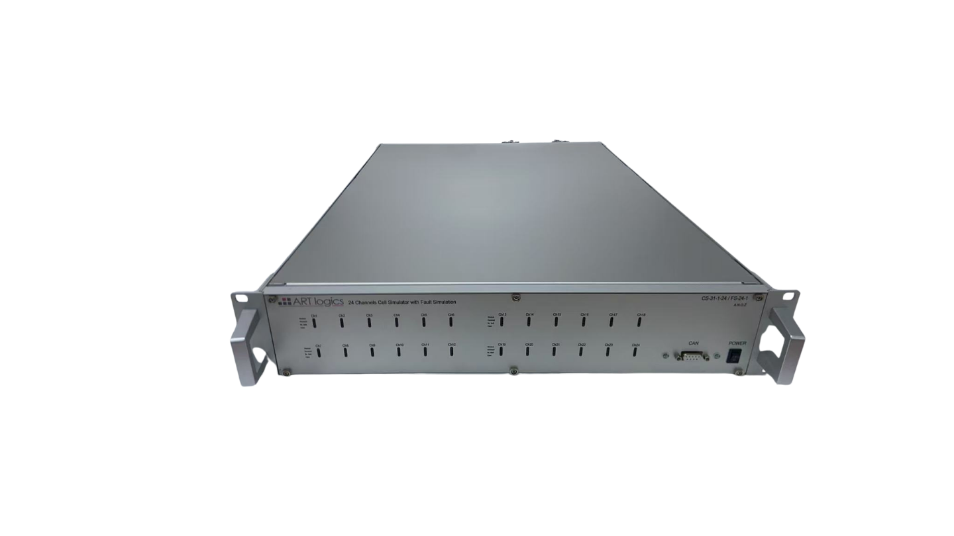
User Guide

Certification and quality assurance

This series of instruments fully meet the nominal technical indicators in the manual.

Protection of solid service

Art-Logics Company provides one for the materials and manufacture of this product from the date of shipment Years of quality warranty service (warranty service except for the following warranty restrictions).

If this product needs warranty service or repair, please return the product to Art-Logics Company Fixed maintenance unit.

- For products sent back to Art-Logics for warranty services, customers must send them in advance One-way shipping rates delivered to Art-Logics repair units, Art-Logics Company will be negative. Responsible for paying the return freight.

- Products returned to Art-Logics for warranty services from other countries Freight, customs duties, and other taxes shall be borne by the customer.

Protection of consolidation restrictions

The retention service does not apply to damage resulting from:

- Products modified or repaired by customers themselves;
- Damage caused by the circuit installed by the customer or operating it outside the specified environment. Damage due to the product;
- The product model or body serial number has been altered, deleted, removed or unidentifiable;
- Damage caused by accidents, including but not limited to lightning strikes, water intake, fire, Abuse or negligence.

Catalogue
Certification and quality assurance 2
Protection of solid service 2
Protection of consolidation restrictions 2
1. Quick reference 4
1.1 Product profile 4
1.2. Introduction of the product 5
Interface 5
PIN Definition 5
NTC Connector PIN Map 9
1.3 Accessories introduction 10
2. Installation and debugging 11
2.1 Connect the power cord 11
2.2 Connect communication lines 12
2.3 Setup 12
2.4 Communication debugging 14
3. How to use it 15
3.1 Installation of software and driver 15
3.2 Run by ART logics Application 15
3.2.1. Standalone Cell Simulator 15
3.2.2. Offline Data 18
3.3 Direct Control 20
Prepare 20
Initial the Cell Simulator 20
Cell Voltage Output 20
Cell Voltage Measurement 21
Cell Current Measurement 21
Fault Simulation: 22
3.4 Advanced configuration 26
a3.4 Set and read by CAN communication 28
3.5 Labview VI 29
4. Technical specifications 30
4.1. Main technical parameters 30
5.FAQ 31

1. Quick reference

This section briefly describes the functions of the front panel, rear panel and the interface of the instrument to ensure a quick understanding before operating the instrument. The appearance, structure, and interface function of the instrument, each operating feature are not detailed in this chapter, it is only a quick reference guide, help you quickly familiarize yourself with the operating characteristics of the instrument.

♦ product profile
♦ Hardware interface introduction
♦ Accessories Introduction

1.1 Product profile

Cell simulation Can provide 6-channel battery simulation, 16-bit ADC, channel isolation, or channel series output.
Users can choose to use Ethernet TCP, USB-C, CAN or RS-232 as communication interfaces to configure the channel parameters and monitor the measurement data. It can also be extended with multiple Cell Simulation cards, using 1 computer control.

More function points, technical indicators and innovation points are described as follows:
(1) The voltage range is 0-7V
(2) Voltage accuracy of 1 mV
(3) 18 channels, channel isolation, support series extendable
(4) Support for battery analog charge and discharge
(5) Ethernet TCP, USB-C, RS-232, and CAN communication interfaces
(6) Provided for both C # and LabVIEW API

1.2. Introduction of the product

Interface
(1) 220VAC Power supply connection
(2) SD card slot
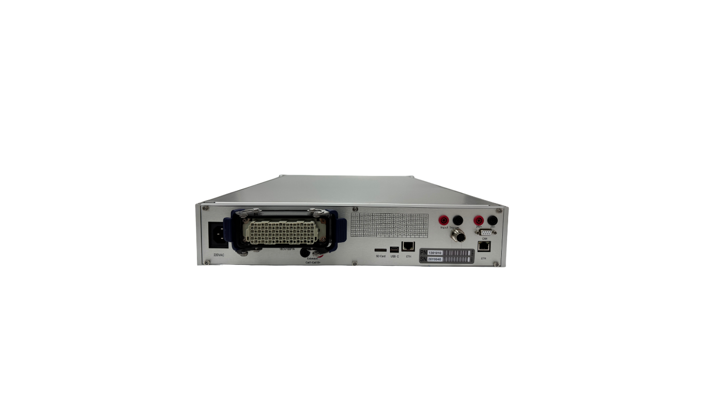
(3) RS232 Serial port
(4) Ethernet connector
(5) CAN connector
(6) 24 Cells outputs ports - RC
(6) 8 NTC outputs ports - Round
(7) Fault simulation status lights

3

2
6
7
5
4

PIN Definition
Connector 1 - Front Panel | Connector 2 - Rear Panel
香蕉接头 - 前面板 | 矩形连接器 - 后面板
CELL1- | RC-1
CELL1_SEN- | RC-2
CELL1_SEN+ | RC-3
CELL1+ | RC-4
CELL2- | RC-5
CELL2_SEN- | RC-6
CELL2_SEN+ | RC-7
CELL2+ | RC-8
CELL3- | RC-9
CELL3_SEN- | RC-10
CELL3_SEN+ | RC-11
CELL3+ | RC-12
CELL4- | RC-13
CELL4_SEN- | RC-14
CELL4_SEN+ | RC-15
CELL4+ | RC-16
CELL5- | RC-17
CELL5_SEN- | RC-18
CELL5_SEN+ | RC-19
CELL5+ | RC-20
CELL6- | RC-21
CELL6_SEN- | RC-22
CELL6_SEN+ | RC-23
CELL6+ | RC-24
CELL7- | RC-25
CELL7_SEN- | RC-26
CELL7_SEN+ | RC-27
CELL7+ | RC-28
CELL8- | RC-29
CELL8_SEN- | RC-30
CELL8_SEN+ | RC-31
CELL8+ | RC-32
CELL9- | RC-33
CELL9_SEN- | RC-34
CELL9_SEN+ | RC-35
CELL9+ | RC-36
CELL10- | RC-37
CELL10_SEN- | RC-38
CELL10_SEN+ | RC-39
CELL10+ | RC-40
CELL11- | RC-41
CELL11_SEN- | RC-42
CELL11_SEN+ | RC-43
CELL11+ | RC-44
CELL12- | RC-45
CELL12_SEN- | RC-46
CELL12_SEN+ | RC-47
CELL12+ | RC-48
CELL13- | RC-49
CELL13_SEN- | RC-50
CELL13_SEN+ | RC-51
CELL13+ | RC-52
CELL14- | RC-53
CELL14_SEN- | RC-54
CELL14_SEN+ | RC-55
CELL14+ | RC-56
CELL15- | RC-57
CELL15_SEN- | RC-58
CELL15_SEN+ | RC-59
CELL15+ | RC-60
CELL16- | RC-61
CELL16_SEN- | RC-62
CELL16_SEN+ | RC-63
CELL16+ | RC-64
CELL17- | RC-65
CELL17_SEN- | RC-66
CELL17_SEN+ | RC-67
CELL17+ | RC-68
CELL18- | RC-69
CELL18_SEN- | RC-70
CELL18_SEN+ | RC-71
CELL18+ | RC-72
CELL19- | RC-73
CELL19_SEN- | RC-74
CELL19_SEN+ | RC-75
CELL19+ | RC-76
CELL20- | RC-77
CELL20_SEN- | RC-78
CELL20_SEN+ | RC-79
CELL20+ | RC-80
CELL21- | RC-81
CELL21_SEN- | RC-82
CELL21_SEN+ | RC-83
CELL21+ | RC-84
CELL22- | RC-85
CELL22_SEN- | RC-86
CELL22_SEN+ | RC-87
CELL22+ | RC-88
CELL23- | RC-89
CELL23_SEN- | RC-90
CELL23_SEN+ | RC-91
CELL23+ | RC-92
CELL24- | RC-93
CELL24_SEN- | RC-94
CELL24_SEN+ | RC-95
CELL24+ | RC-96

PIN map of Connector 2
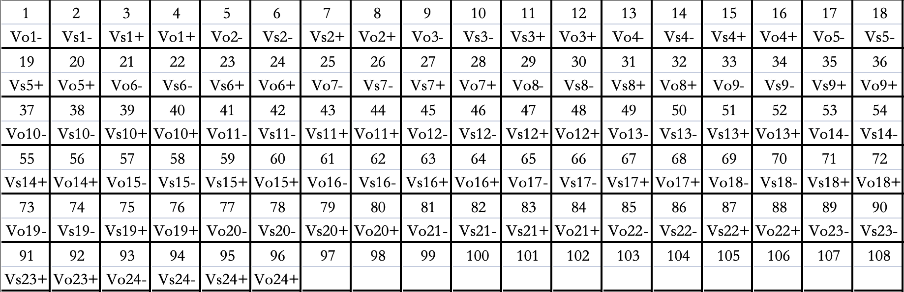

NTC Connector PIN Map

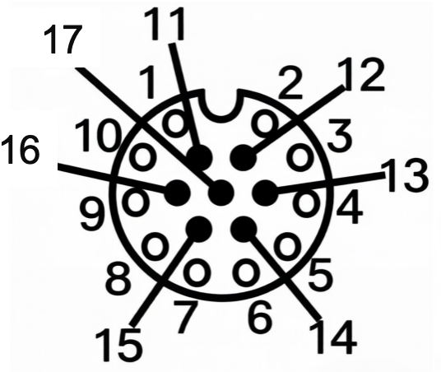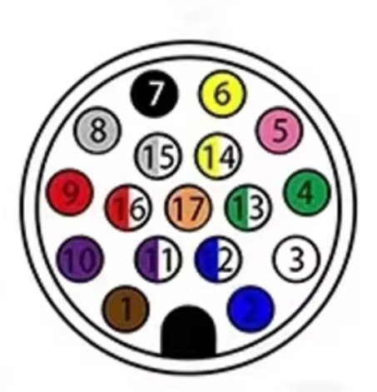

PIN No. | NTC Output
1 | NTC1+
2 | NTC1-
3 | NTC2+
4 | NTC2-
5 | NTC3+
6 | NTC3-
7 | NTC4+
8 | NTC4-
9 | NTC5+
10 | NTC5-
11 | NTC6+
12 | NTC6-
13 | NTC7+
14 | NTC7-
15 | NTC8+
16 | NTC8-
17 | /

1.3 Accessories introduction

- 220VAC power supply

- SD card (Optional)

For offline operation mode and storage the test data.
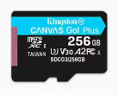

- USB-C data cable

Used to connect the Cell Simulation to the computer when using serial port communication.

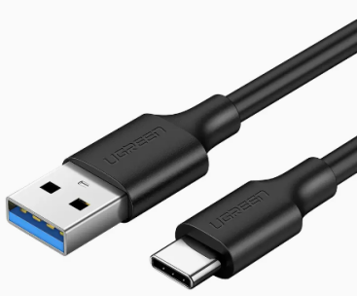
·

- Network cable

Used to connect a Cell Simulation to a computer when using Ethernet communication.

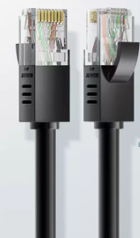

- Software development data

Contains the computer software Cell Simulator.
Note: See the Development Manual for more details

2. Installation and debugging

♦ Connects the power cord
♦ Connects communication lines
♦ Communication debugging
♦ Company receives objects

2.1 Connect the power cord
Before connecting the power cord

To prevent electric shock and damage to the instrument, observe the following precautions.

warn

· Before connecting the power cord, ensure that the supply voltage matches the rated input voltage of the instrument.

· Before connecting the power cord, make sure the power switch is off and confirm that there is no dangerous voltage at the terminal.

· To prevent electric shock and fire, please use the power cord provided by the company.

· Be sure to connect the input power line to the AC distribution box with protective grounding. Do not use the wiring board without protective grounding.

· Do not use the extension power cord without a protection grounding, otherwise the protection function will fail.

· Ensure that the protective cover is protected around the power cord terminals to avoid accidental contact Voltage causes potential personal safety hazards.

take care

The safety agency requires that there must be a way to physically disconnect the AC power cord from the device. In the final Ann Disconnect equipment (switch or circuit breaker) must be provided in the installation. The disconnection device must be close to this device and easy to reach (so that In operation), and the disconnect device for this device must be marked.
Wiring method

- Verify that the switch of the instrument is turned off.
- Make that there is no dangerous voltage at the interface.
- Connect the 24V power supply

2.2 Connect communication lines

The instrument provides 3 communication modes.

- The first type is serial port communication, and the instrument end is the interface of Type-C.
- The second type is Ethernet communication, and the instrument end is the interface of Ethernet.
- The third type is the CAN communication, and the instrument end is the CAN protocol D B9 interface.

2.3 Setup

The connection mode between the instrument and the object to be measured is directly connected, and the schematic diagram is as follows.
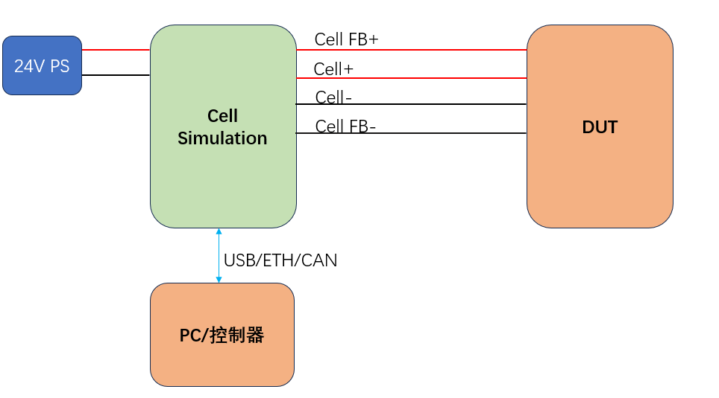
Single-device direct-connection mode
PC/Controller

The series interface on each cell board is connected to form a multi-device series output mode.
Each COM port should be different when using USB communication;
Each IP address is different when using Ethernet; refer to Cells Simulation Board-User Manual.pdf for modifying the IP address. In the 1.3.3 Ethernet TCP Communication chapter;
The device ID is different when using CAN protocol; refer to Cells Simulation Board-User Manual.pdf for modifying the device address. The 1.3.6 Board Identification chapter written in the document;

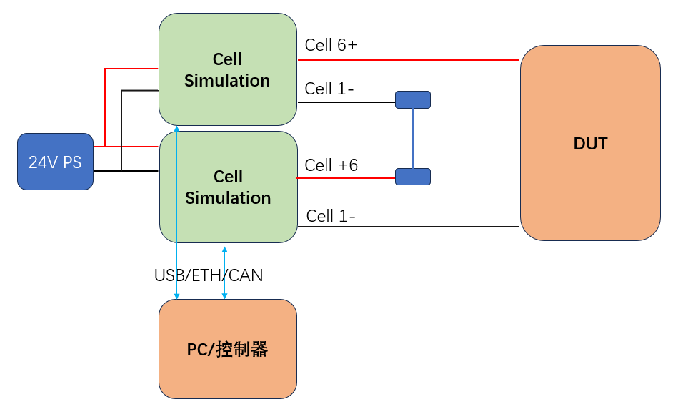
Cell 1-
Cell 18+
Cell 1-
Cell 18+
PC/Controller

2.4 Communication debugging
Set IP address for laptop

- Connect the power line to the communication line.
- Configure the computer IP and the instrument IP in the same previous LAN segment. the initial IP of the instrument is 192.168.0.149. The following example changes the computer address to 192.168.1.127.

Note: Only directly connected to the network cable, the computer needs to configure IP 1 times, not later.

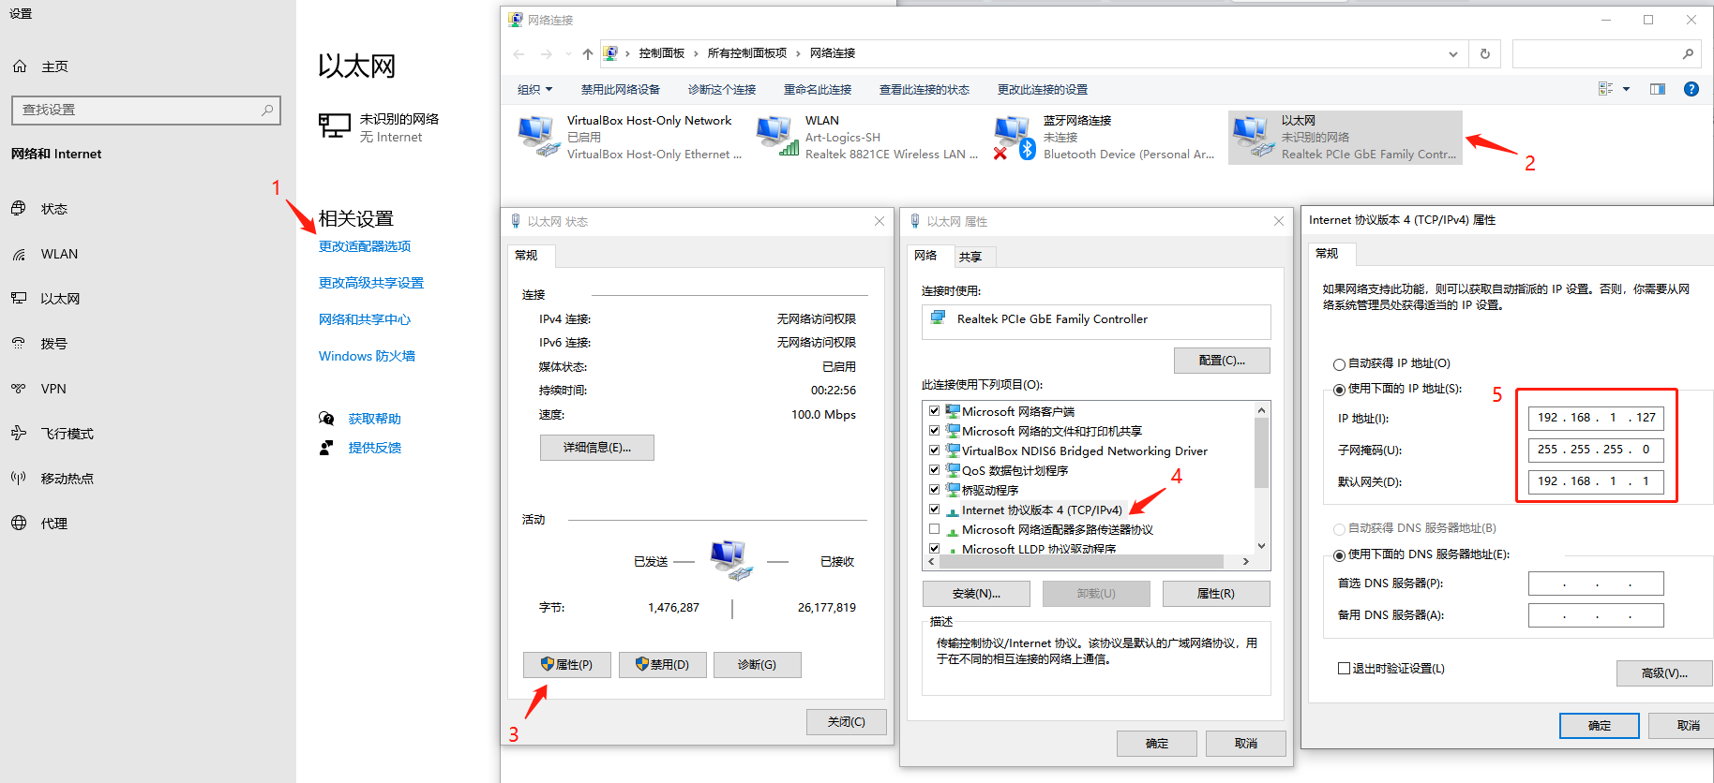

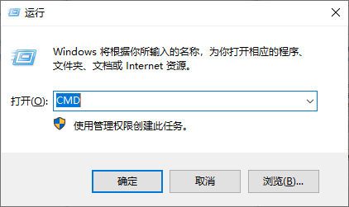
3. Press WIN + R at the same time and enter CMD to open the command line window
4. Enter ping 192.168.0.120. Check whether the network communication is normal. If there is a reply below, the Ethernet connection is normal.

Note: Please ensure the cell simulator is in the same network of the computer.

3. How to use it

This section details how to use the instrument, including installation of software and driver, functional configuration and applications, and parameters set up.

♦ Installation of the software and the driver
♦ Basic Commands
♦ Advanced configuration
♦ Set and read by CAN communication

3.1 Installation of software and driver

Copy the software, the driver is contained in the software, no need to install.

Run by ART logics Application

3.2.1. Standalone Cell Simulator

When opening the application, click on the 'Standalone Cell Simulator' button to establish a connection between your PC and the Cell Simulator.

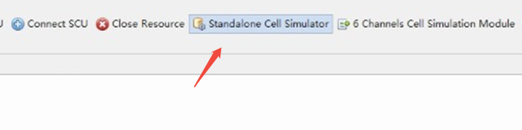

The following page will then open. First, select 'USB Port' or ‘TCP/IP’ and verify that it is the desired port. Then click on 'Check the Connected Device.' The computer will then attempt to connect to the device. If the connection is successful, a message with the board's identifier will appear. Otherwise, please check your system's connections.
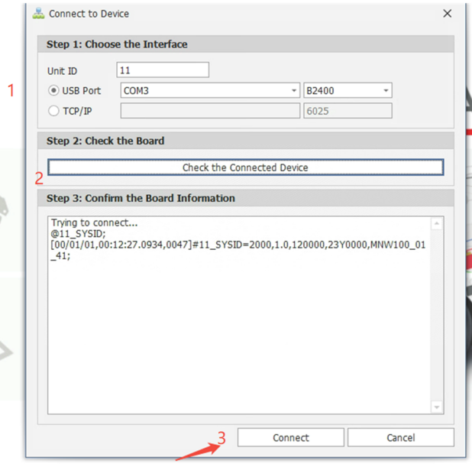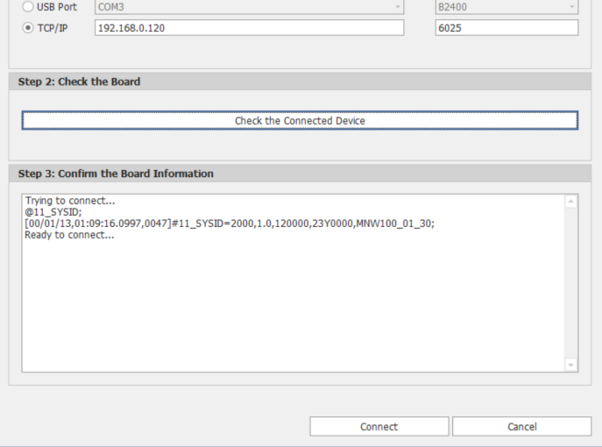

Unit ID is default 11, no need to change.
Next, click on the 'Connect' button to access the application's features. You will then reach the following interface:

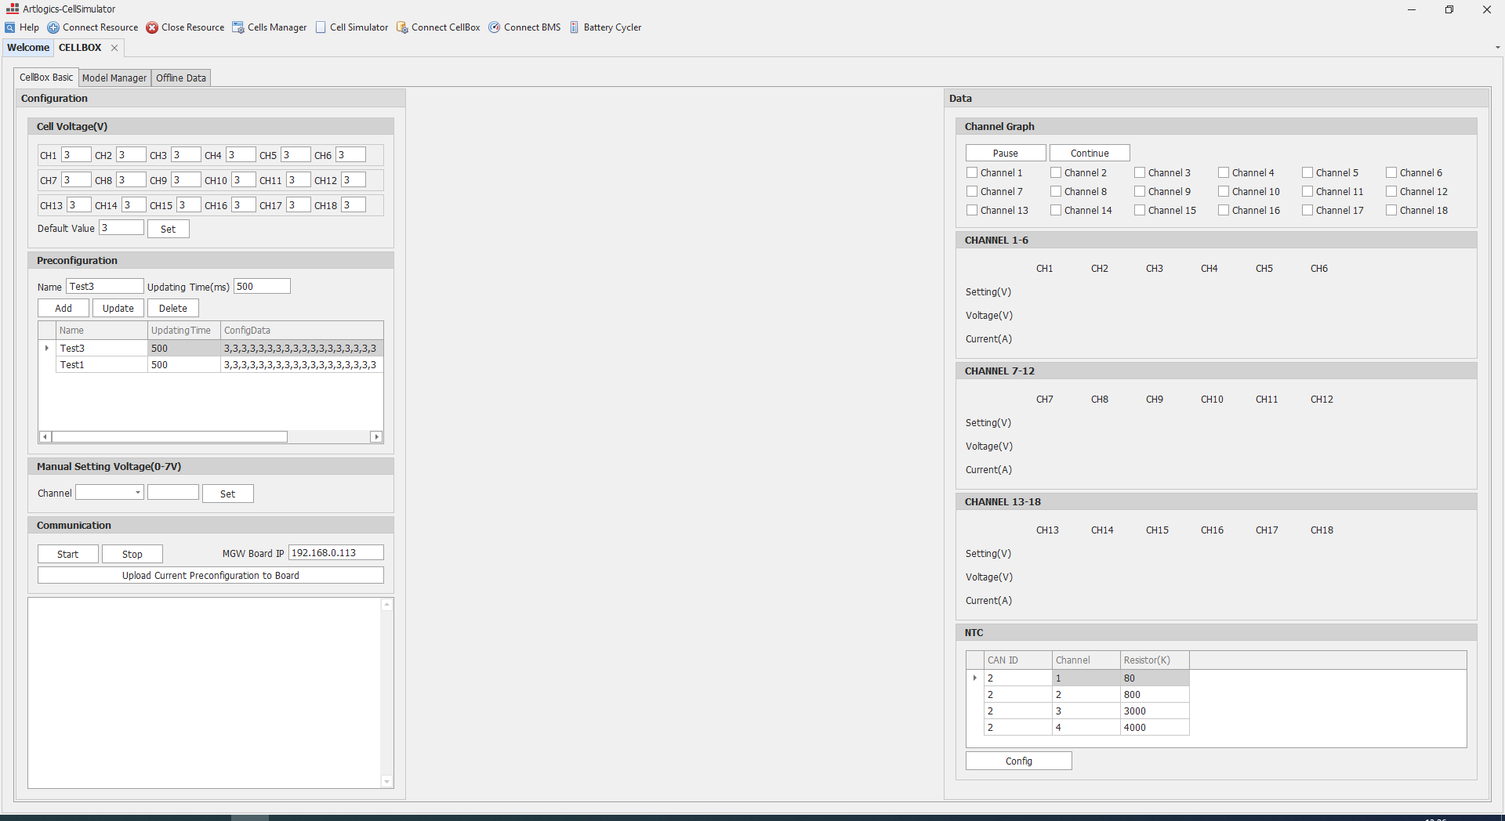

This interface is divided into three parts:
- In the red section, you'll find the test configuration. Here, you can create, save, and launch tests.
- In the yellow section, test results will be displayed in real-time. You can select specific channels to view detailed values.
- In the blue section, graphs of the selected channels will be displayed, providing an overview of voltage changes.
To perform a test:
- Start by entering the voltage values to assign to each channel. You can assign a default value that will be applied to all channels.
- Save your preconfiguration by specifying an updating time, then click on 'Add.'
- In the 'Communication' area, verify that the IP address is correct, then click on 'Start.' The test will then begin, and you should see a display similar to this one:
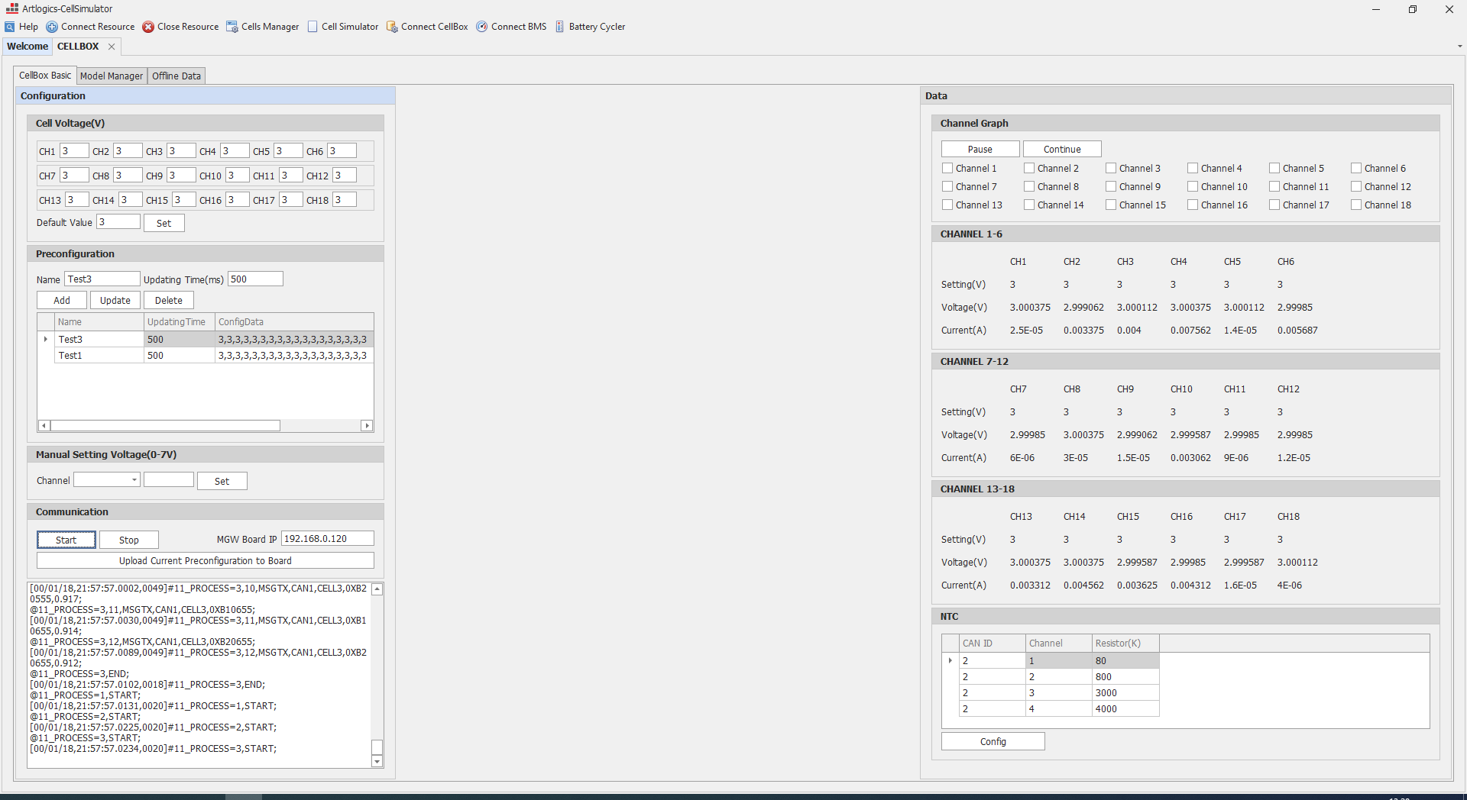

You can display graphs for specific channels by checking the boxes in the 'Channel Graph' section.

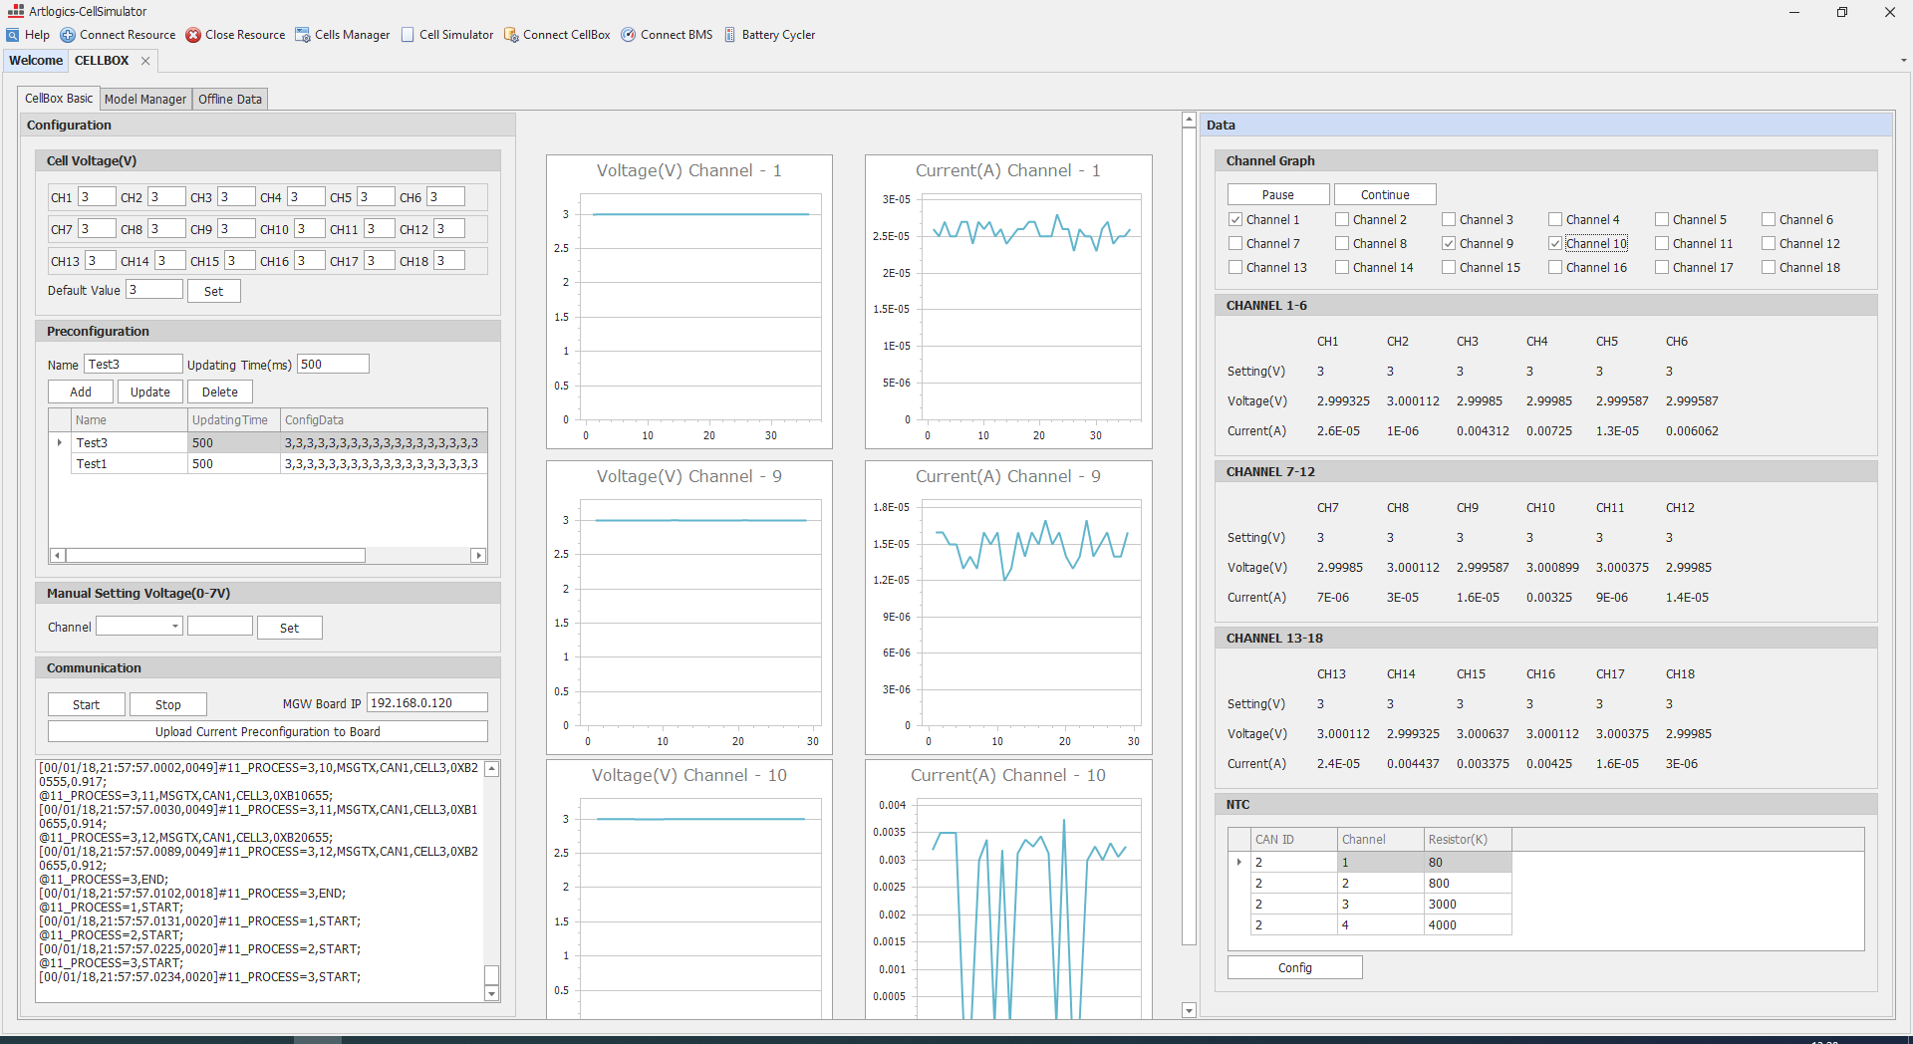

3.2.2. Offline Data

To use the application with TCP/IP connection, reconnect the device by selecting TCP/IP:

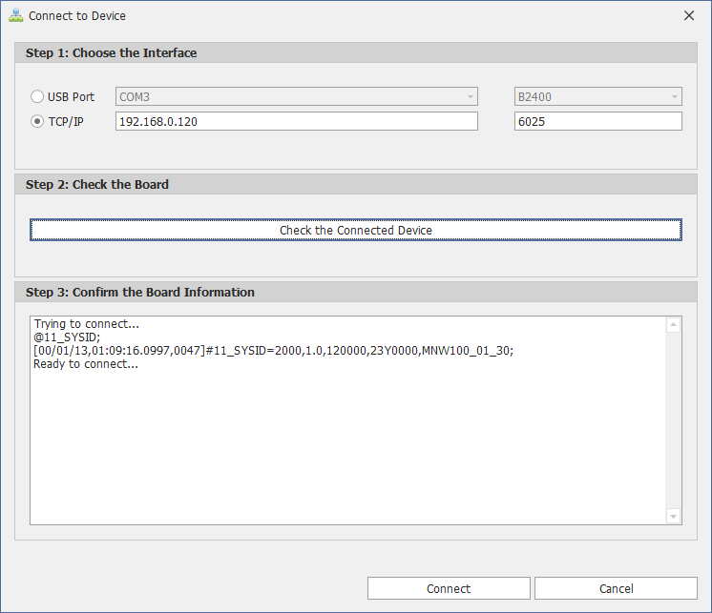

Next, go to the 'Offline Data' tab and click on 'Connect' after verifying the IP address of the board. You will then be able to view logged results stored in the SD card. To do this, select a LOG.txt file and click on 'Download Selected File.' Wait a moment, and the file will be available in the folder on the right side of the screen. You can then select it and click on 'Replay Selected Log.'

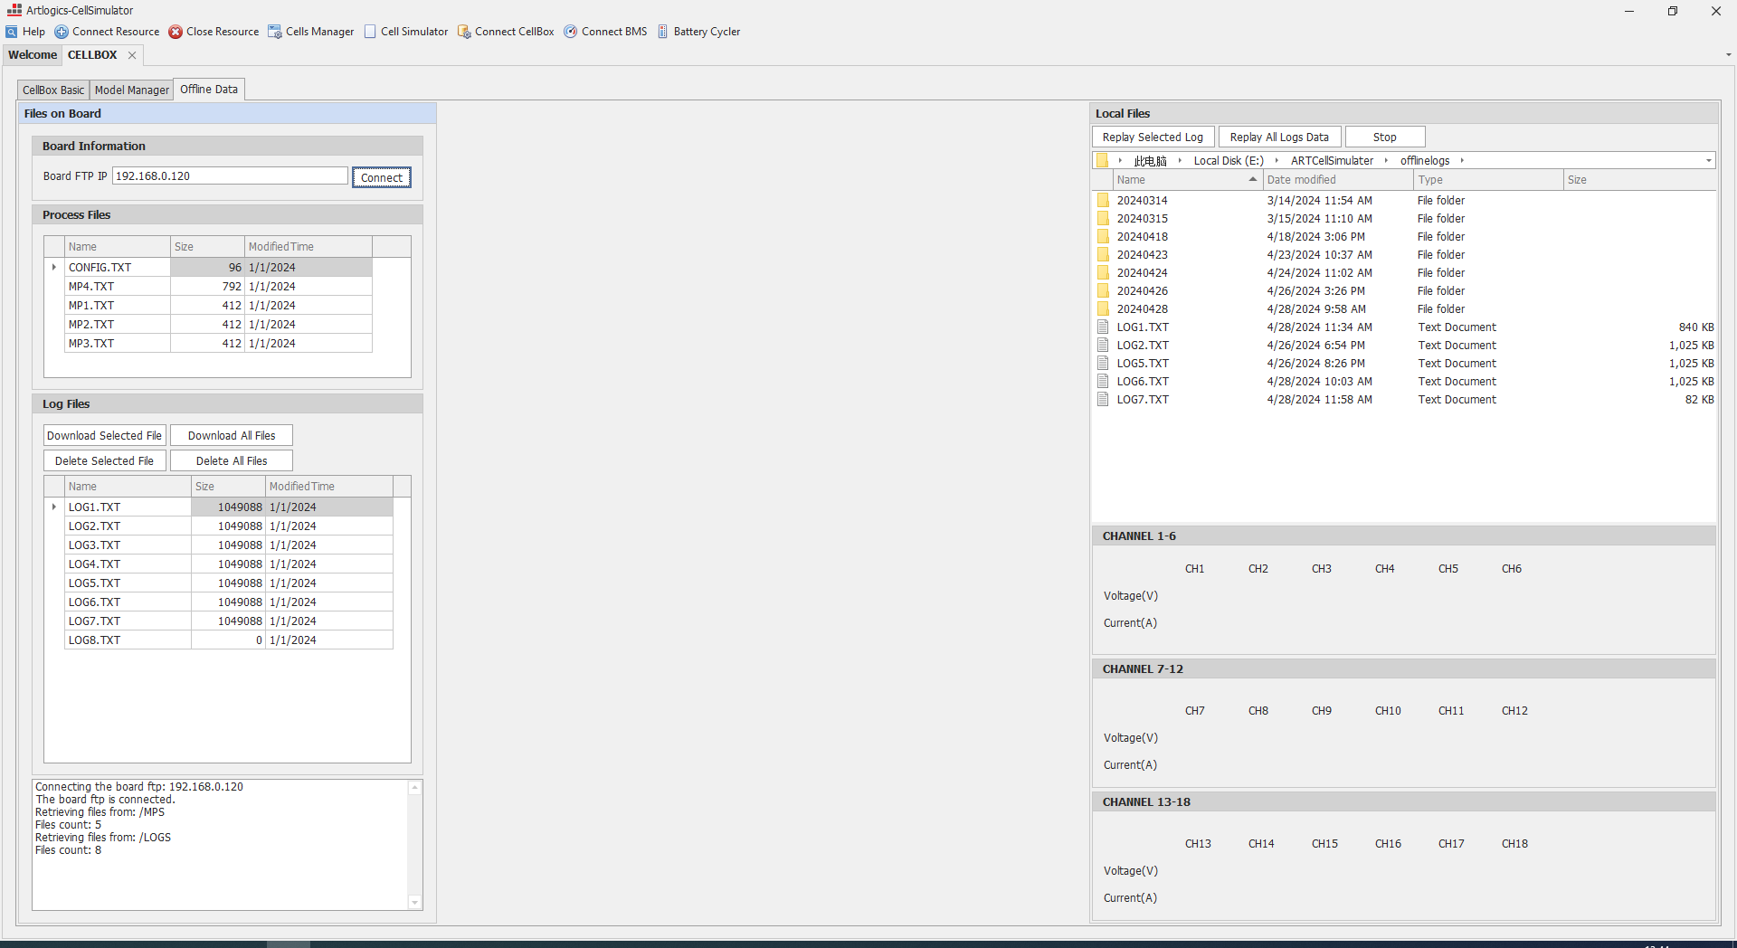

You will then be able to view logged results stored in the SD card. To do this, select a LOG.txt file and click on 'Download Selected File.' Wait a moment, and the file will be available in the folder on the right side of the screen. You can then select it and click on 'Replay Selected Log.' You will obtain the graphs recorded in the logs as follows:

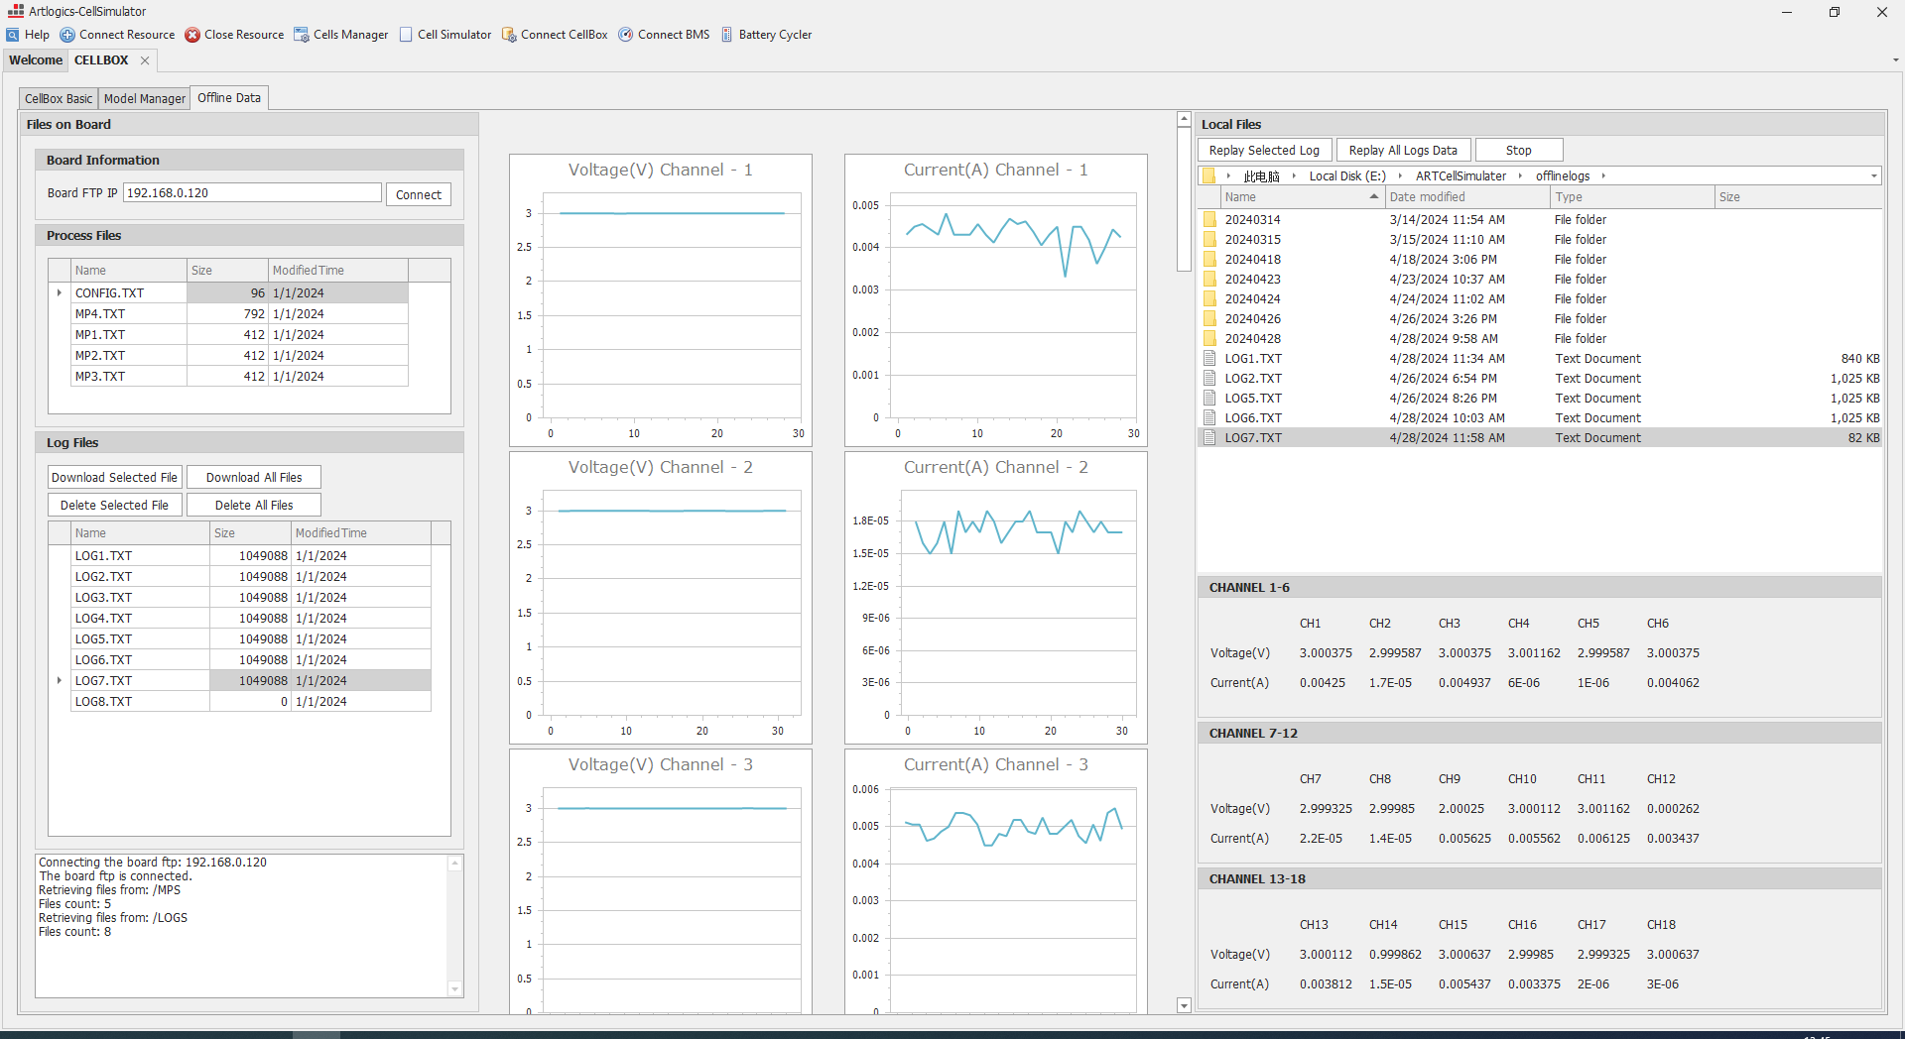

Direct Control

Prepare
Connect the Cell Simulator by USB or TCP/IP

Initial the Cell Simulator

@11_SYSID;
@11_CAN=1,STOP;
@11_TSTOP;
@11_CONFIG=CAN1,BAUDRATE,500K;
@11_CONFIG=CAN1,TX,CELL11,STD,0X11; // for ch1 to ch6
@11_CONFIG=CAN1,TX,CELL12,STD,0X12; // for ch7 to ch12
@11_CONFIG=CAN1,TX,CELL13,STD,0X13; // for ch13 to ch18
@11_CONFIG=CAN2,BAUDRATE,500K;
@11_CONFIG=CAN2,TX,NTC,STD,0X01;
@11_TSTRT;
@11_CAN=1,START;

Cell Voltage Output

The voltage output of a cell can be set via a command by providing the channel and the voltage value. In addition,
calibration values (scale, offset) are used to adjust the voltage output for each cell.
The parameters of the voltage output of a cell

Command:

0xA1 CH SN B1 B2 B3 B4 0x55

● Acknowledge:
Same as the command.
● Description:
– CH: Cell number from 0 to 6. CH=0 means to set all channel as the same value.
– SN: 0x00 for a positive value or 0x11 for a negative value.
– B1 to B4: 4 bytes of the voltage value to set.

● Example:

@11_MSGTX=CAN1,CELL11,0XA10000380055; // Set Ch1 to Ch6 for 3.8V
@11_MSGTX=CAN1,CELL12,0XA10000380055; // Set Ch7 to Ch12 for 3.8V
@11_MSGTX=CAN1,CELL13,0XA10000380055; // Set Ch13 to Ch18 for 3.8V

Cell Voltage Measurement
The board offers voltage measurement by sending command and providing the channel. In addition, calibration
values (scale, offset) are used to adjust the voltage measurement for each cell. The parameters of the voltage measurement of a cell

● Command:

@11_MSGTX=CAN1,CELL11,0xB1 CH 0x55

● Acknowledge:
0xB1 CH SN B1 B2 B3 B4 0x50

● Description:
– CH: Cell number from 1 to 6.
– SN: 0x00 for a positive value or 0x11 for a negative value.
– B1 to B4: 4 bytes of the voltage value to set.

● Example:

#11_CAN=1,STD,0X11,0XB101002999266050;// Ch 01 voltage is 2.9992660V
#11_CAN=1,STD,0X12,0XB101002999266050;// Ch 07 voltage is 2.9992660V
#11_CAN=1,STD,0X13,0XB101002999266050;// Ch 13 voltage is 2.9992660V

Cell Current Measurement

The board offers current measurement by sending command and providing the channel. In addition, calibration values (scale, offset) are used to adjust the current measurement for each cell.
The current measurement has two ranges, a low current and a high current range. The parameters of the low current measurement of a cell

● Command:

@11_MSGTX=CAN1,CELL11,0xBB CH 0x55 // for Ch01 to Ch06 current measurement at high range.
@11_MSGTX=CAN1,CELL12,0xBB CH 0x55// for Ch07 to Ch12 current measurement at high range.
@11_MSGTX=CAN1,CELL13,0xBB CH 0x55// for Ch13 to Ch18 current measurement at high range.

@11_MSGTX=CAN1,CELL11,0xBC CH 0x55 // for Ch01 to Ch06 current measurement at low range.
@11_MSGTX=CAN1,CELL12,0xBC CH 0x55// for Ch07 to Ch12 current measurement at low range.
@11_MSGTX=CAN1,CELL13,0xBC CH 0x55// for Ch13 to Ch18 current measurement at low range.

● Acknowledge:
0xBB CH SN B1 B2 B3 B4 0x50 // to get current measurement at high right
0xBC CH SN B1 B2 B3 B4 0x50 // to get current measurement at low righ

● Description:
– CH: Cell number from 1 to 6.
– SN: 0x00 for a positive value or 0x11 for a negative value.
– B1 to B4: 4 bytes of the voltage value to set.

● Example:

#11_CAN=1,STD,0X13,0XBB01000000034050; // Ch 13 current is 0.0000340A

Fault Simulation:

You may set 4 status of cell channels: Open, No fault, Reversed and Short cut.
When turn on the cell simulator, it will stay at “Open” by default.
Please set to “No fault”, if you want normal output.

 | OPEN
CH1 | @11_CLRDIG=5; | @11_CLRDIG=6; | @11_CLRDIG=7; | @11_CLRDIG=8;
CH2 | @11_CLRDIG=10; | @11_CLRDIG=11; | @11_CLRDIG=12; | @11_CLRDIG=13;
CH3 | @11_CLRDIG=15; | @11_CLRDIG=16; | @11_CLRDIG=17; | @11_CLRDIG=18;
CH4 | @11_CLRDIG=20; | @11_CLRDIG=21; | @11_CLRDIG=22; | @11_CLRDIG=23;
CH5 | @11_CLRDIG=25; | @11_CLRDIG=26; | @11_CLRDIG=27; | @11_CLRDIG=28;
CH6 | @11_CLRDIG=30; | @11_CLRDIG=31; | @11_CLRDIG=32; | @11_CLRDIG=33;
CH7 | @11_CLRDIG=35; | @11_CLRDIG=36; | @11_CLRDIG=37; | @11_CLRDIG=38;
CH8 | @11_CLRDIG=40; | @11_CLRDIG=41; | @11_CLRDIG=42; | @11_CLRDIG=43;
CH9 | @11_CLRDIG=45; | @11_CLRDIG=46; | @11_CLRDIG=47; | @11_CLRDIG=48;
CH10 | @11_CLRDIG=50; | @11_CLRDIG=51; | @11_CLRDIG=52; | @11_CLRDIG=53;
CH11 | @11_CLRDIG=55; | @11_CLRDIG=56; | @11_CLRDIG=57; | @11_CLRDIG=58;
CH12 | @11_CLRDIG=60; | @11_CLRDIG=61; | @11_CLRDIG=62; | @11_CLRDIG=63;
CH13 | @11_CLRDIG=65; | @11_CLRDIG=66; | @11_CLRDIG=67; | @11_CLRDIG=68;
CH14 | @11_CLRDIG=70; | @11_CLRDIG=71; | @11_CLRDIG=72; | @11_CLRDIG=73;
CH15 | @11_CLRDIG=75; | @11_CLRDIG=76; | @11_CLRDIG=77; | @11_CLRDIG=78;
CH16 | @11_CLRDIG=80; | @11_CLRDIG=81; | @11_CLRDIG=82; | @11_CLRDIG=83;
CH17 | @11_CLRDIG=85; | @11_CLRDIG=86; | @11_CLRDIG=87; | @11_CLRDIG=88;
CH18 | @11_CLRDIG=90; | @11_CLRDIG=91; | @11_CLRDIG=92; | @11_CLRDIG=93;
CH19 | @11_CLRDIG=94; | @11_CLRDIG=95; | @11_CLRDIG=96; | @11_CLRDIG=97;
CH20 | @11_CLRDIG=98; | @11_CLRDIG=99; | @11_CLRDIG=100; | @11_CLRDIG=101;
CH21 | @11_CLRDIG=102; | @11_CLRDIG=103; | @11_CLRDIG=104; | @11_CLRDIG=105;
CH22 | @11_CLRDIG=106; | @11_CLRDIG=107; | @11_CLRDIG=108; | @11_CLRDIG=109;
CH23 | @11_CLRDIG=110; | @11_CLRDIG=111; | @11_CLRDIG=112; | @11_CLRDIG=113;
CH24 | @11_CLRDIG=114; | @11_CLRDIG=114; | @11_CLRDIG=115; | @11_CLRDIG=116;

 | NO FAULT
CH1 | @11_SETDIG=5; | @11_SETDIG=6; | @11_CLRDIG=7; | @11_CLRDIG=8;
CH2 | @11_SETDIG=10; | @11_SETDIG=11; | @11_CLRDIG=12; | @11_CLRDIG=13;
CH3 | @11_SETDIG=15; | @11_SETDIG=16; | @11_CLRDIG=17; | @11_CLRDIG=18;
CH4 | @11_SETDIG=20; | @11_SETDIG=21; | @11_CLRDIG=22; | @11_CLRDIG=23;
CH5 | @11_SETDIG=25; | @11_SETDIG=26; | @11_CLRDIG=27; | @11_CLRDIG=28;
CH6 | @11_SETDIG=30; | @11_SETDIG=31; | @11_CLRDIG=32; | @11_CLRDIG=33;
CH7 | @11_SETDIG=35; | @11_SETDIG=36; | @11_CLRDIG=37; | @11_CLRDIG=38;
CH8 | @11_SETDIG=40; | @11_SETDIG=41; | @11_CLRDIG=42; | @11_CLRDIG=43;
CH9 | @11_SETDIG=45; | @11_SETDIG=46; | @11_CLRDIG=47; | @11_CLRDIG=48;
CH10 | @11_SETDIG=50; | @11_SETDIG=51; | @11_CLRDIG=52; | @11_CLRDIG=53;
CH11 | @11_SETDIG=55; | @11_SETDIG=56; | @11_CLRDIG=57; | @11_CLRDIG=58;
CH12 | @11_SETDIG=60; | @11_SETDIG=61; | @11_CLRDIG=62; | @11_CLRDIG=63;
CH13 | @11_SETDIG=65; | @11_SETDIG=66; | @11_CLRDIG=67; | @11_CLRDIG=68;
CH14 | @11_SETDIG=70; | @11_SETDIG=71; | @11_CLRDIG=72; | @11_CLRDIG=73;
CH15 | @11_SETDIG=75; | @11_SETDIG=76; | @11_CLRDIG=77; | @11_CLRDIG=78;
CH16 | @11_SETDIG=80; | @11_SETDIG=81; | @11_CLRDIG=82; | @11_CLRDIG=83;
CH17 | @11_SETDIG=85; | @11_SETDIG=86; | @11_CLRDIG=87; | @11_CLRDIG=88;
CH18 | @11_SETDIG=90; | @11_SETDIG=91; | @11_CLRDIG=92; | @11_CLRDIG=93;
CH19 | @11_SETDIG=94; | @11_CLRDIG=95; | @11_CLRDIG=96; | @11_CLRDIG=97;
CH20 | @11_SETDIG=98; | @11_CLRDIG=99; | @11_CLRDIG=100; | @11_CLRDIG=101;
CH21 | @11_SETDIG=102; | @11_CLRDIG=103; | @11_CLRDIG=104; | @11_CLRDIG=105;
CH22 | @11_SETDIG=106; | @11_CLRDIG=107; | @11_CLRDIG=108; | @11_CLRDIG=109;
CH23 | @11_SETDIG=110; | @11_CLRDIG=111; | @11_CLRDIG=112; | @11_CLRDIG=113;
CH24 | @11_SETDIG=114; | @11_CLRDIG=114; | @11_CLRDIG=115; | @11_CLRDIG=116;

 | REVERSED
CH1 | @11_SETDIG=5; | @11_CLRDIG=6; | @11_SETDIG=7; | @11_CLRDIG=8;
CH2 | @11_SETDIG=10; | @11_CLRDIG=11; | @11_SETDIG=12; | @11_CLRDIG=13;
CH3 | @11_SETDIG=15; | @11_CLRDIG=16; | @11_SETDIG=17; | @11_CLRDIG=18;
CH4 | @11_SETDIG=20; | @11_CLRDIG=21; | @11_SETDIG=22; | @11_CLRDIG=23;
CH5 | @11_SETDIG=25; | @11_CLRDIG=26; | @11_SETDIG=27; | @11_CLRDIG=28;
CH6 | @11_SETDIG=30; | @11_CLRDIG=31; | @11_SETDIG=32; | @11_CLRDIG=33;
CH7 | @11_SETDIG=35; | @11_CLRDIG=36; | @11_SETDIG=37; | @11_CLRDIG=38;
CH8 | @11_SETDIG=40; | @11_CLRDIG=41; | @11_SETDIG=42; | @11_CLRDIG=43;
CH9 | @11_SETDIG=45; | @11_CLRDIG=46; | @11_SETDIG=47; | @11_CLRDIG=48;
CH10 | @11_SETDIG=50; | @11_CLRDIG=51; | @11_SETDIG=52; | @11_CLRDIG=53;
CH11 | @11_SETDIG=55; | @11_CLRDIG=56; | @11_SETDIG=57; | @11_CLRDIG=58;
CH12 | @11_SETDIG=60; | @11_CLRDIG=61; | @11_SETDIG=62; | @11_CLRDIG=63;
CH13 | @11_SETDIG=65; | @11_CLRDIG=66; | @11_SETDIG=67; | @11_CLRDIG=68;
CH14 | @11_SETDIG=70; | @11_CLRDIG=71; | @11_SETDIG=72; | @11_CLRDIG=73;
CH15 | @11_SETDIG=75; | @11_CLRDIG=76; | @11_SETDIG=77; | @11_CLRDIG=78;
CH16 | @11_SETDIG=80; | @11_CLRDIG=81; | @11_SETDIG=82; | @11_CLRDIG=83;
CH17 | @11_SETDIG=85; | @11_CLRDIG=86; | @11_SETDIG=87; | @11_CLRDIG=88;
CH18 | @11_SETDIG=90; | @11_CLRDIG=91; | @11_SETDIG=92; | @11_CLRDIG=93;
CH19 | @11_SETDIG=94; | @11_CLRDIG=95; | @11_SETDIG=96; | @11_CLRDIG=97;
CH20 | @11_SETDIG=98; | @11_CLRDIG=99; | @11_SETDIG=100; | @11_CLRDIG=101;
CH21 | @11_SETDIG=102; | @11_CLRDIG=103; | @11_SETDIG=104; | @11_CLRDIG=105;
CH22 | @11_SETDIG=106; | @11_CLRDIG=107; | @11_SETDIG=108; | @11_CLRDIG=109;
CH23 | @11_SETDIG=110; | @11_CLRDIG=111; | @11_SETDIG=112; | @11_CLRDIG=113;
CH24 | @11_SETDIG=114; | @11_CLRDIG=114; | @11_SETDIG=115; | @11_CLRDIG=116;

 | SHORTCUT
CH1 | @11_CLRDIG=5; | @11_CLRDIG=6; | @11_CLRDIG=7; | @11_SETDIG=8;
CH2 | @11_CLRDIG=10; | @11_CLRDIG=11; | @11_CLRDIG=12; | @11_SETDIG=13;
CH3 | @11_CLRDIG=15; | @11_CLRDIG=16; | @11_CLRDIG=17; | @11_SETDIG=18;
CH4 | @11_CLRDIG=20; | @11_CLRDIG=21; | @11_CLRDIG=22; | @11_SETDIG=23;
CH5 | @11_CLRDIG=25; | @11_CLRDIG=26; | @11_CLRDIG=27; | @11_SETDIG=28;
CH6 | @11_CLRDIG=30; | @11_CLRDIG=31; | @11_CLRDIG=32; | @11_SETDIG=33;
CH7 | @11_CLRDIG=35; | @11_CLRDIG=36; | @11_CLRDIG=37; | @11_SETDIG=38;
CH8 | @11_CLRDIG=40; | @11_CLRDIG=41; | @11_CLRDIG=42; | @11_SETDIG=43;
CH9 | @11_CLRDIG=45; | @11_CLRDIG=46; | @11_CLRDIG=47; | @11_SETDIG=48;
CH10 | @11_CLRDIG=50; | @11_CLRDIG=51; | @11_CLRDIG=52; | @11_SETDIG=53;
CH11 | @11_CLRDIG=55; | @11_CLRDIG=56; | @11_CLRDIG=57; | @11_SETDIG=58;
CH12 | @11_CLRDIG=60; | @11_CLRDIG=61; | @11_CLRDIG=62; | @11_SETDIG=63;
CH13 | @11_CLRDIG=65; | @11_CLRDIG=66; | @11_CLRDIG=67; | @11_SETDIG=68;
CH14 | @11_CLRDIG=70; | @11_CLRDIG=71; | @11_CLRDIG=72; | @11_SETDIG=73;
CH15 | @11_CLRDIG=75; | @11_CLRDIG=76; | @11_CLRDIG=77; | @11_SETDIG=78;
CH16 | @11_CLRDIG=80; | @11_CLRDIG=81; | @11_CLRDIG=82; | @11_SETDIG=83;
CH17 | @11_CLRDIG=85; | @11_CLRDIG=86; | @11_CLRDIG=87; | @11_SETDIG=88;
CH18 | @11_CLRDIG=90; | @11_CLRDIG=91; | @11_CLRDIG=92; | @11_SETDIG=93;
CH19 | @11_CLRDIG=94; | @11_CLRDIG=95; | @11_CLRDIG=96; | @11_SETDIG=97;
CH20 | @11_CLRDIG=98; | @11_CLRDIG=99; | @11_CLRDIG=100; | @11_SETDIG=101;
CH21 | @11_CLRDIG=102; | @11_CLRDIG=103; | @11_CLRDIG=104; | @11_SETDIG=105;
CH22 | @11_CLRDIG=106; | @11_CLRDIG=107; | @11_CLRDIG=108; | @11_SETDIG=109;
CH23 | @11_CLRDIG=110; | @11_CLRDIG=111; | @11_CLRDIG=112; | @11_SETDIG=113;
CH24 | @11_CLRDIG=114; | @11_CLRDIG=114; | @11_CLRDIG=115; | @11_SETDIG=116;

3.4 Advanced configuration

In the software, the voltage measurement keeps sending by as a default timing. It cannot be changed. If you want to customize the process (like how often to send a response), you can send commands as the “Cells Simulation Board - User Manual” - section 1.8 Actions Sequencer.

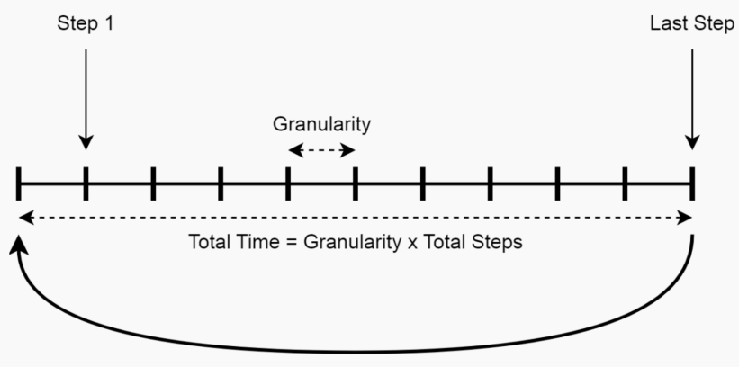

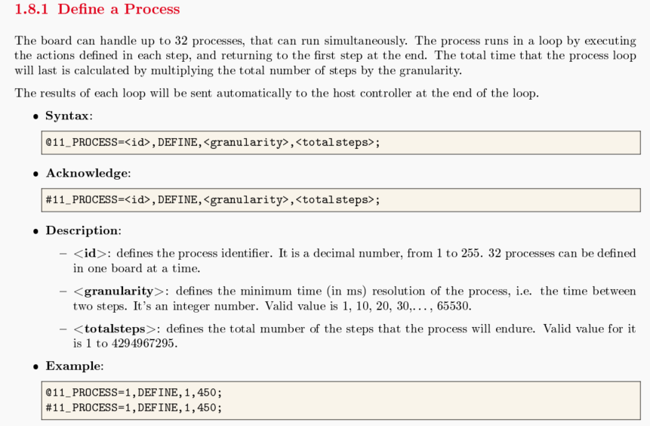

- Example

/* Process 1 to set all channels voltage */

@11_PROCESS=1,DEFINE,1,180;
@11_PROCESS=1,1,MSGTX,CAN1,CELL11,0XA100002000000055;
@11_PROCESS=1,61,MSGTX,CAN1,CELL12,0XA100002000000055;
@11_PROCESS=1,121,MSGTX,CAN1,CELL13,0XA100002000000055;
@11_PROCESS=1,END;

/* Process 2 to get all channels voltage */

@11_PROCESS=2,DEFINE,1,101;
@11_PROCESS=2,1,MSGTX,CAN1,CELL11,0XB10155;
@11_PROCESS=2,5,MSGTX,CAN1,CELL11,0XB10255;
@11_PROCESS=2,10,MSGTX,CAN1,CELL11,0XB10355;
@11_PROCESS=2,15,MSGTX,CAN1,CELL11,0XB10455;
@11_PROCESS=2,20,MSGTX,CAN1,CELL11,0XB10555;
@11_PROCESS=2,25,MSGTX,CAN1,CELL11,0XB10655;
@11_PROCESS=2,30,MSGTX,CAN1,CELL12,0XB10155;
@11_PROCESS=2,35,MSGTX,CAN1,CELL12,0XB10255;
@11_PROCESS=2,40,MSGTX,CAN1,CELL12,0XB10355;
@11_PROCESS=2,45,MSGTX,CAN1,CELL12,0XB10455;
@11_PROCESS=2,50,MSGTX,CAN1,CELL12,0XB10555;
@11_PROCESS=2,55,MSGTX,CAN1,CELL12,0XB10655;
@11_PROCESS=2,60,MSGTX,CAN1,CELL13,0XB10155;
@11_PROCESS=2,65,MSGTX,CAN1,CELL13,0XB10255;
@11_PROCESS=2,70,MSGTX,CAN1,CELL13,0XB10355;
@11_PROCESS=2,75,MSGTX,CAN1,CELL13,0XB10455;
@11_PROCESS=2,80,MSGTX,CAN1,CELL13,0XB10555;
@11_PROCESS=2,85,MSGTX,CAN1,CELL13,0XB10655;
@11_PROCESS=2,END;

/* Process 3 to get all channels current measurement current at high range */

@11_PROCESS=3,DEFINE,1,101;
@11_PROCESS=3,1,MSGTX,CAN1,CELL11,0XBB0155;
@11_PROCESS=3,5,MSGTX,CAN1,CELL11,0XBB0255;
@11_PROCESS=3,10,MSGTX,CAN1,CELL11,0XBB0355;
@11_PROCESS=3,15,MSGTX,CAN1,CELL11,0XBB0455;
@11_PROCESS=3,20,MSGTX,CAN1,CELL11,0XBB0555;
@11_PROCESS=3,25,MSGTX,CAN1,CELL11,0XBB0655;
@11_PROCESS=3,30,MSGTX,CAN1,CELL12,0XBB0155;
@11_PROCESS=3,35,MSGTX,CAN1,CELL12,0XBB0255;
@11_PROCESS=3,40,MSGTX,CAN1,CELL12,0XBB0355;
@11_PROCESS=3,45,MSGTX,CAN1,CELL12,0XBB0455;
@11_PROCESS=3,50,MSGTX,CAN1,CELL12,0XBB0555;
@11_PROCESS=3,55,MSGTX,CAN1,CELL12,0XBB0655;
@11_PROCESS=3,60,MSGTX,CAN1,CELL13,0XBB0155;
@11_PROCESS=3,65,MSGTX,CAN1,CELL13,0XBB0255;
@11_PROCESS=3,70,MSGTX,CAN1,CELL13,0XBB0355;
@11_PROCESS=3,75,MSGTX,CAN1,CELL13,0XBB0455;
@11_PROCESS=3,80,MSGTX,CAN1,CELL13,0XBB0555;
@11_PROCESS=3,85,MSGTX,CAN1,CELL13,0XBB0655;
@11_PROCESS=3,END;

● Command:

@11_PROCESS=1,START,LOOPS,1; // to start process 1 for once.
@11_PROCESS=1,STOP; // to stop process1

Note:
for the process of set voltage output, please use command: “@11_PROCESS=1,START,LOOPS,1;”
By process start and stop way, user can change voltage, current.

a3.4 Set and read by CAN communication

It’s also allowed user to set output voltage and read cell voltage and current by CAN.
- Connect CAN line to the cell simulator by any CAN tool.
- Send command to set the output voltage for each cell channel.
- Read voltage or current by CAN command.
- Detail commands see “Cells Simulation Board - User Manual”

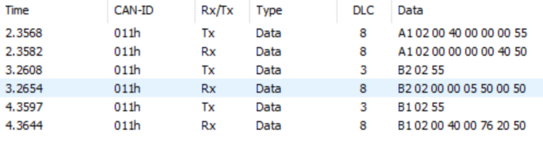

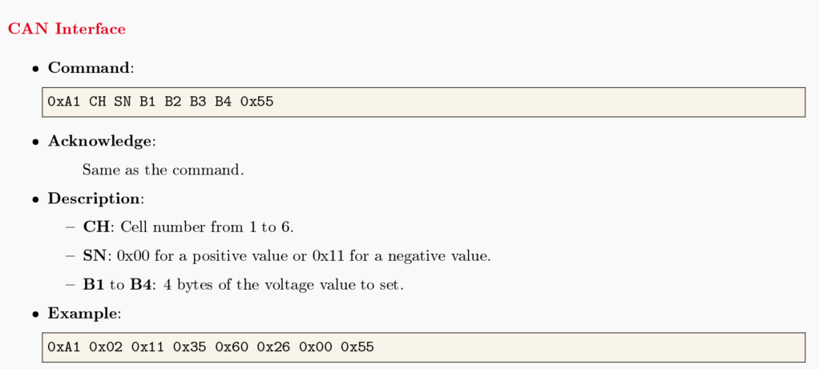

3.5 Labview VI

There are two VI folders for the equipment. One for TCP and one for USB.
You can program as your test requirements.

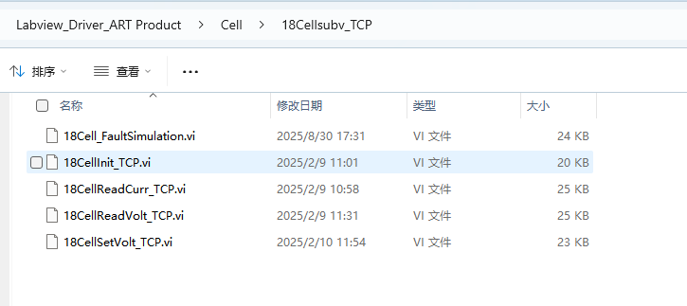

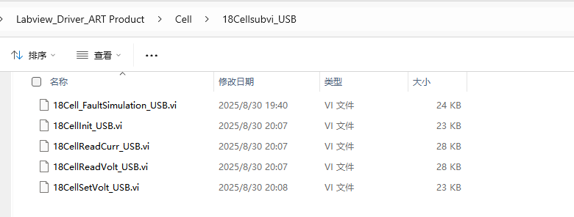

To set the fault simulation by Labview VI
You need to send the commands accordingly see 3.3 fault simulation.
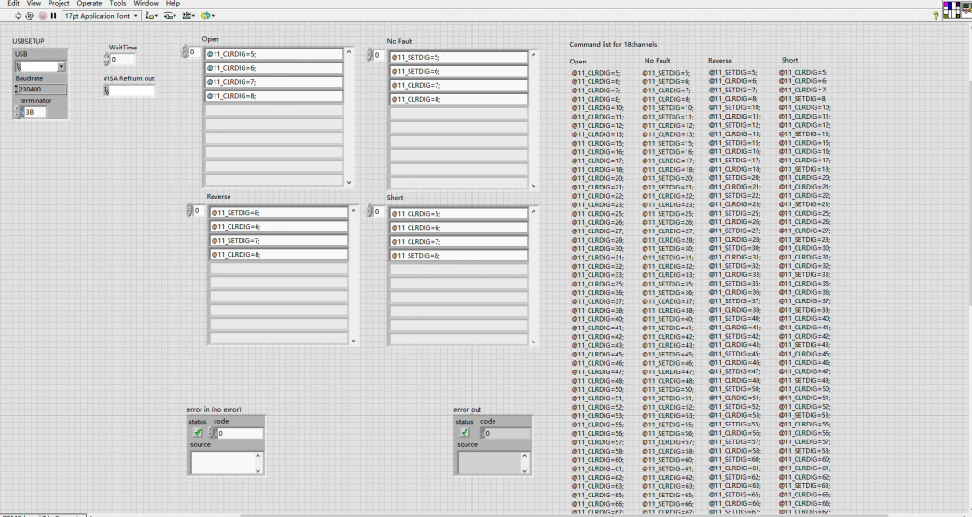

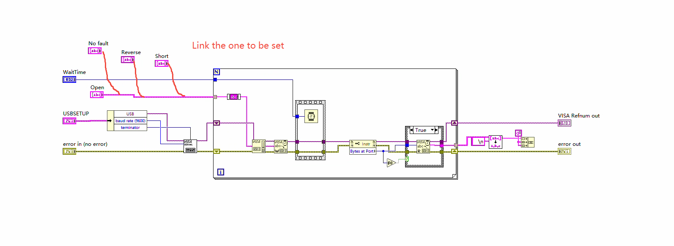

4. Technical specifications

♦ Main technical parameters

4.1. Main technical parameters

Analog voltage output | parameter
Channel | 18 channels
Resolution ratio | 16bit
Output voltage range (usual / maximum) | 0-7 V
Voltage accuracy | ±1m V
Charging current | 0-1A
Discharge current | -500 to 500 mA
Current accuracy | 1mA/±5u A

Connector interface | parameter
Ethernet | TCP/IP  10/100 Mbps link  Programmable source code, gateway, and mask ip
USB-C | USB 2.0  5V power supply
CAN | Standard CAN protocol for 500 Kbps

Environment
Working humidity | 10 – 90 RH% without condensation
Storage humidity | And 5 – 95% RH without condensation

5.FAQ
5.1 Connection warning

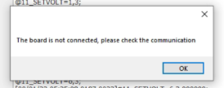

- Click and try to connect again
- Check USB/IP configuration and setup as section 2.4
- Plug the connector again

