REversion: v1.10 - 2026/03/10

24 Channels
Cell Simulator with Fault Simulation 3U Rack
User Guide

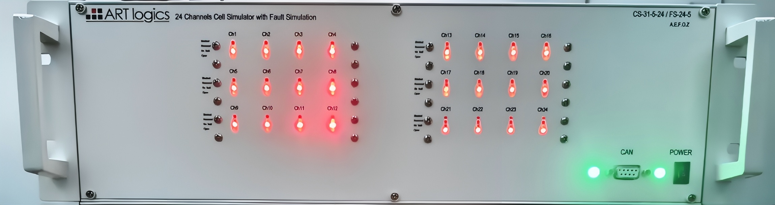

Certification and quality assurance

This series of instruments fully meet the nominal technical indicators in the manual.

Protection of solid service

Art-Logics Company provides one for the materials and manufacture of this product from the date of shipment Years of quality warranty service (warranty service except for the following warranty restrictions).

If this product needs warranty service or repair, please return the product to Art-Logics Company Fixed maintenance unit.

- For products sent back to Art-Logics for warranty services, customers must send them in advance One-way shipping rates delivered to Art-Logics repair units, Art-Logics Company will be negative. Responsible for paying the return freight.

- Products returned to Art-Logics for warranty services from other countries Freight, customs duties, and other taxes shall be borne by the customer.

Protection of consolidation restrictions

The retention service does not apply to damage resulting from:

- Products modified or repaired by customers themselves;
- Damage caused by the circuit installed by the customer or operating it outside the specified environment. Damage due to the product;
- The product model or body serial number has been altered, deleted, removed or unidentifiable;
- Damage caused by accidents, including but not limited to lightning strikes, water intake, fire, Abuse or negligence.

Catalogue
Certification and quality assurance 2
Protection of solid service 2
Protection of consolidation restrictions 2
1. Quick reference 4
1.1 Product profile 4
1.2. Introduction of the product 5
Interface 5
PIN Definition 5
NTC Connector PIN Map 9
1.3 Accessories introduction 10
2. Installation and debugging 11
2.1 Connect the power cord 11
2.2 Connect communication lines 12
2.3 Setup 12
2.4 Communication debugging 14
3. How to use it 15
3.1 Installation of software and driver 15
3.2 Run by ART logics Application 15
3.2.1. Standalone Cell Simulator 15
3.2.2. Offline Data 18
3.3 Direct Control 20
Prepare 20
Initial the Cell Simulator 20
Cell Voltage Output 20
Cell Voltage Measurement 21
Cell Current Measurement 21
Fault Simulation: 22
3.4 Advanced configuration 26
a3.4 Set and read by CAN communication 28
3.5 Labview VI 29
4. Technical specifications 30
4.1. Main technical parameters 30
5.FAQ 31

1. Quick reference

This section briefly describes the functions of the front panel, rear panel and the interface of the instrument to ensure a quick understanding before operating the instrument. The appearance, structure, and interface function of the instrument, each operating feature are not detailed in this chapter, it is only a quick reference guide, help you quickly familiarize yourself with the operating characteristics of the instrument.

♦ product profile
♦ Hardware interface introduction
♦ Accessories Introduction

1.1 Product profile

Cell simulation Can provide 6-channel battery simulation, 16-bit ADC, channel isolation, or channel series output.
Users can choose to use Ethernet TCP, USB-C*, CAN or RS-232 as communication interfaces to configure the channel parameters and monitor the measurement data. It can also be extended with multiple Cell Simulation cards, using 1 computer control.

More function points, technical indicators and innovation points are described as follows:
(1) The voltage range is 0-7V / 0-5V
(2) Voltage accuracy of 1 mV
(3) 24 channels, channel isolation, support series extendable
(4) Support for battery analog charge and discharge
(5) Ethernet TCP, USB-C*, RS-232, and CAN communication interfaces
(6) Provided for both C # and LabVIEW API

Note: * Optional, depends on the series.

1.2. Introduction of the product

Interface
(1) 220VAC Power supply connection
(2) SD card slot
(3) RS232 Serial port
(4) Ethernet connector
(5) CAN connector
(6) 24 Cells outputs ports - RC
(6) 8 NTC outputs ports - Round*
(7) Fault simulation status lights
(8) 24V DC Input
(9) Fault simulation communication port
(10) Cell simulation TCP control port

- 24ch Cells Simulation with fault simulation - 1A
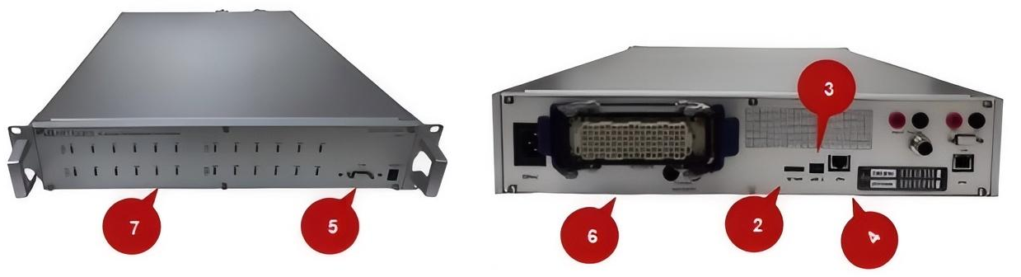
6
8

- 24ch Cells Simulation with fault simulation - 5A
5
7
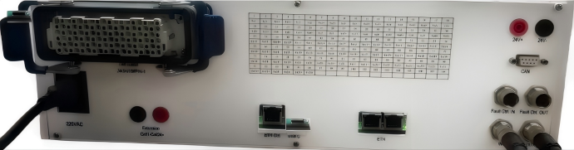
10
9
4
1
5

Note: * is optional

PIN Definition
Connector 1 - Front Panel | Connector 2 - Rear Panel
香蕉接头 - 前面板 | 矩形连接器 - 后面板
CELL1- | RC-1
CELL1_SEN- | RC-2
CELL1_SEN+ | RC-3
CELL1+ | RC-4
CELL2- | RC-5
CELL2_SEN- | RC-6
CELL2_SEN+ | RC-7
CELL2+ | RC-8
CELL3- | RC-9
CELL3_SEN- | RC-10
CELL3_SEN+ | RC-11
CELL3+ | RC-12
CELL4- | RC-13
CELL4_SEN- | RC-14
CELL4_SEN+ | RC-15
CELL4+ | RC-16
CELL5- | RC-17
CELL5_SEN- | RC-18
CELL5_SEN+ | RC-19
CELL5+ | RC-20
CELL6- | RC-21
CELL6_SEN- | RC-22
CELL6_SEN+ | RC-23
CELL6+ | RC-24
CELL7- | RC-25
CELL7_SEN- | RC-26
CELL7_SEN+ | RC-27
CELL7+ | RC-28
CELL8- | RC-29
CELL8_SEN- | RC-30
CELL8_SEN+ | RC-31
CELL8+ | RC-32
CELL9- | RC-33
CELL9_SEN- | RC-34
CELL9_SEN+ | RC-35
CELL9+ | RC-36
CELL10- | RC-37
CELL10_SEN- | RC-38
CELL10_SEN+ | RC-39
CELL10+ | RC-40
CELL11- | RC-41
CELL11_SEN- | RC-42
CELL11_SEN+ | RC-43
CELL11+ | RC-44
CELL12- | RC-45
CELL12_SEN- | RC-46
CELL12_SEN+ | RC-47
CELL12+ | RC-48
CELL13- | RC-49
CELL13_SEN- | RC-50
CELL13_SEN+ | RC-51
CELL13+ | RC-52
CELL14- | RC-53
CELL14_SEN- | RC-54
CELL14_SEN+ | RC-55
CELL14+ | RC-56
CELL15- | RC-57
CELL15_SEN- | RC-58
CELL15_SEN+ | RC-59
CELL15+ | RC-60
CELL16- | RC-61
CELL16_SEN- | RC-62
CELL16_SEN+ | RC-63
CELL16+ | RC-64
CELL17- | RC-65
CELL17_SEN- | RC-66
CELL17_SEN+ | RC-67
CELL17+ | RC-68
CELL18- | RC-69
CELL18_SEN- | RC-70
CELL18_SEN+ | RC-71
CELL18+ | RC-72
CELL19- | RC-73
CELL19_SEN- | RC-74
CELL19_SEN+ | RC-75
CELL19+ | RC-76
CELL20- | RC-77
CELL20_SEN- | RC-78
CELL20_SEN+ | RC-79
CELL20+ | RC-80
CELL21- | RC-81
CELL21_SEN- | RC-82
CELL21_SEN+ | RC-83
CELL21+ | RC-84
CELL22- | RC-85
CELL22_SEN- | RC-86
CELL22_SEN+ | RC-87
CELL22+ | RC-88
CELL23- | RC-89
CELL23_SEN- | RC-90
CELL23_SEN+ | RC-91
CELL23+ | RC-92
CELL24- | RC-93
CELL24_SEN- | RC-94
CELL24_SEN+ | RC-95
CELL24+ | RC-96

PIN map of Connector 2
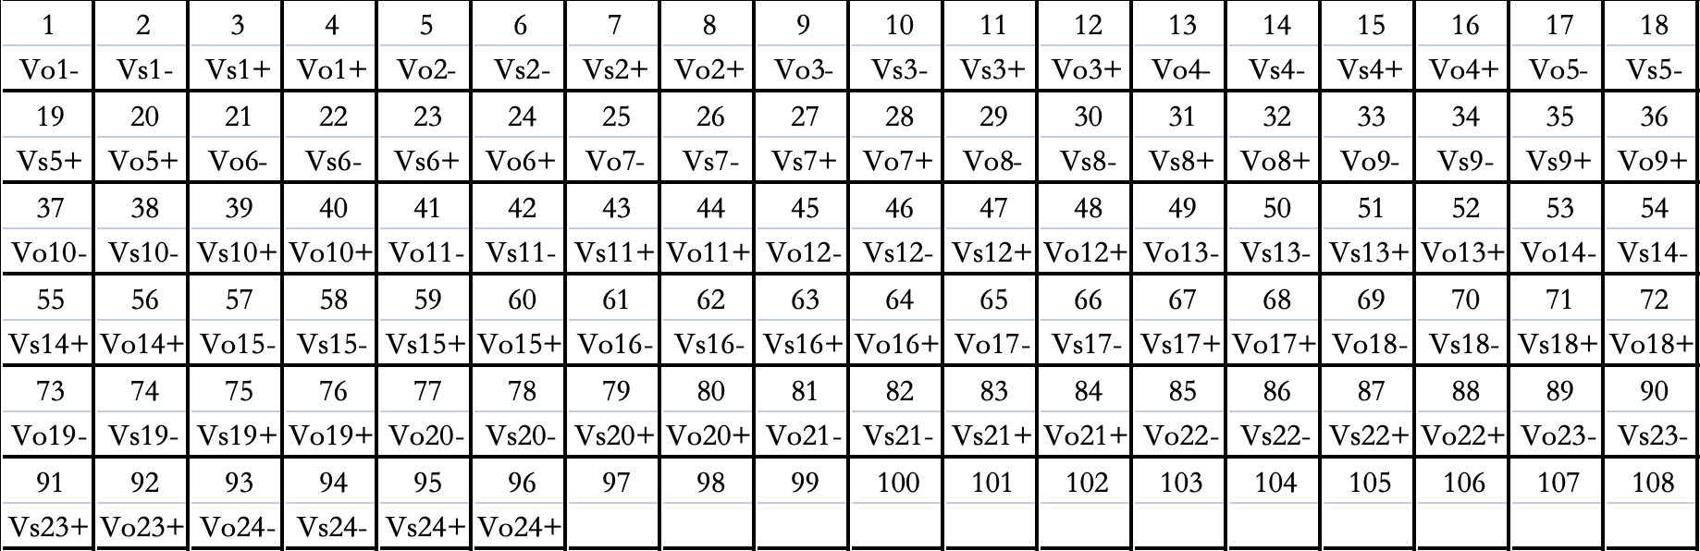

1.3 Accessories introduction

- 220VAC power supply

- USB-C data cable

Used to connect the Cell Simulation to the computer when using serial port communication.

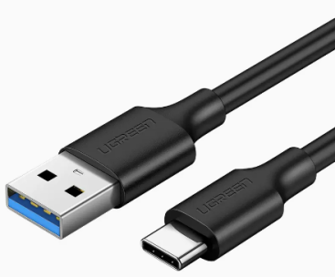
·

- Network cable

Used to connect a Cell Simulation to a computer when using Ethernet communication.

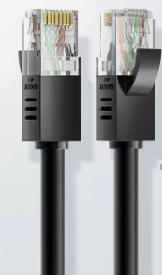

- Software development data

Contains the computer software Cell Simulator.
Note: See the Development Manual for more details

2. Installation and debugging

♦ Connects the power cord
♦ Connects communication lines
♦ Communication debugging
♦ Company receives objects

2.1 Connect the power cord
Before connecting the power cord

To prevent electric shock and damage to the instrument, observe the following precautions.

warn

· Before connecting the power cord, ensure that the supply voltage matches the rated input voltage of the instrument.

· Before connecting the power cord, make sure the power switch is off and confirm that there is no dangerous voltage at the terminal.

· To prevent electric shock and fire, please use the power cord provided by the company.

· Be sure to connect the input power line to the AC distribution box with protective grounding. Do not use the wiring board without protective grounding.

· Do not use the extension power cord without a protection grounding, otherwise the protection function will fail.

· Ensure that the protective cover is protected around the power cord terminals to avoid accidental contact Voltage causes potential personal safety hazards.

take care

The safety agency requires that there must be a way to physically disconnect the AC power cord from the device. In the final Ann Disconnect equipment (switch or circuit breaker) must be provided in the installation. The disconnection device must be close to this device and easy to reach (so that In operation), and the disconnect device for this device must be marked.
Wiring method

- Verify that the switch of the instrument is turned off.
- Make that there is no dangerous voltage at the interface.
- Connect the 24V power supply

2.2 Connect communication lines

The instrument provides 4 communication modes.

- The first type is serial port communication, and the instrument end is the interface of Type-C.
- The second type is Ethernet communication, and the instrument end is the interface of Ethernet.
- The third type is the CAN communication, and the instrument end is the CAN protocol DB9 interface.
- The third type is daisy chain communication, and the instrument end is the the interface of daisy chain.

2.3 Setup

2.3.1 Connect to DUT

The connection mode between the instrument and the object to be measured is directly connected, and the schematic diagram is as follows.
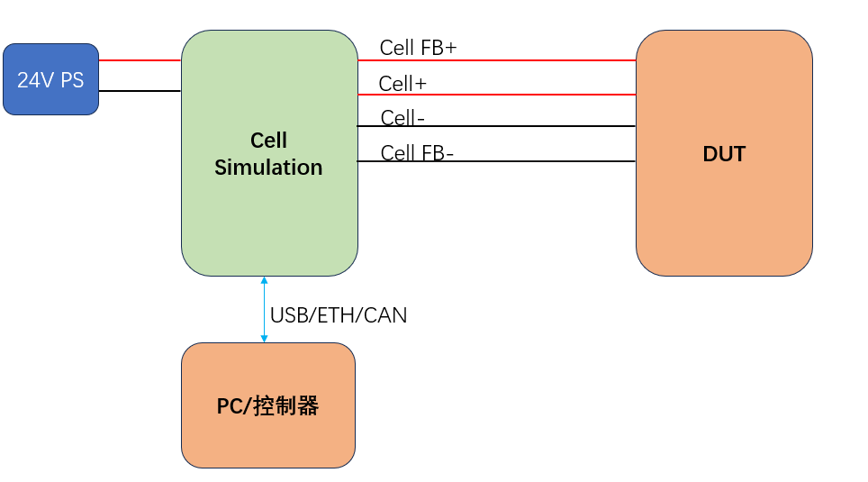
Single-device direct-connection mode
PC/Controller

The series interface on each cell board is connected to form a multi-device series output mode.

2.3.2 Connect multi-cell simulator units
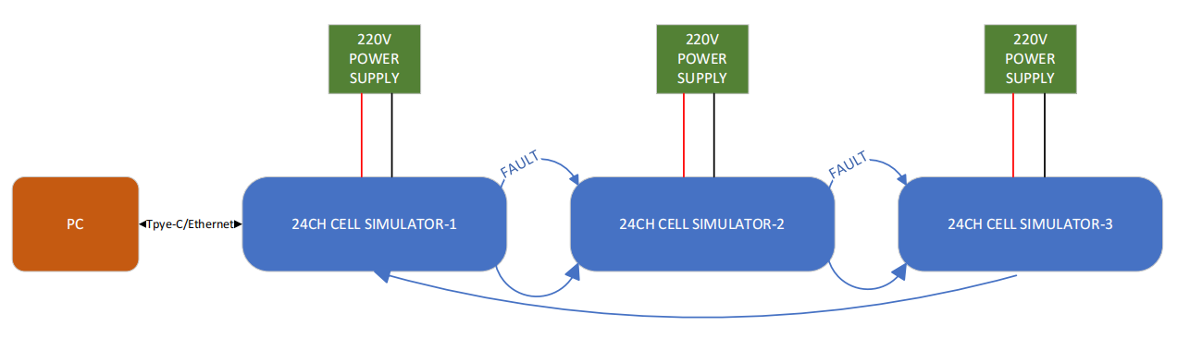
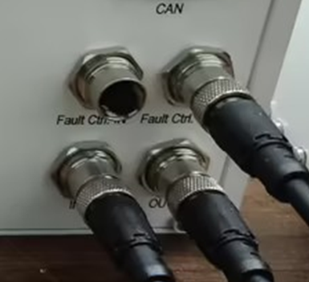

Connect the Fault Ctrl. OUT connector of Cell Box 1 to the Fault Ctrl. IN connector of Cell Box 2 using a data cable. Then, connect the Fault Ctrl. OUT connector of Cell Box 2 to the Fault Ctrl. IN connector of Cell Box 3 to complete the connection.

Connect the OUT connector of Cell Box 1 to the IN connector of Cell Box 2 using a data cable. Then, connect the OUT connector of Cell Box 2 to the IN connector of Cell Box 3. Finally, link the OUT connector of Cell Box 3 to the IN connector of Cell Box 1 to complete the daisy chain communication for the cell box.

2.4 Communication debugging
Set IP address for laptop

- Connect the power line to the communication line.
- Configure the computer IP and the instrument IP in the same previous LAN segment. the initial IP of the instrument is 192.168.0.149. The following example changes the computer address to 192.168.1.127.

Note: Only directly connected to the network cable, the computer needs to configure IP 1 times, not later.

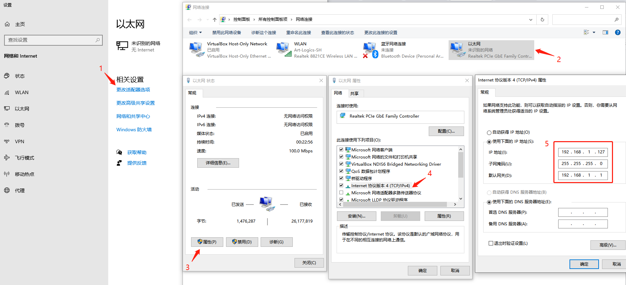

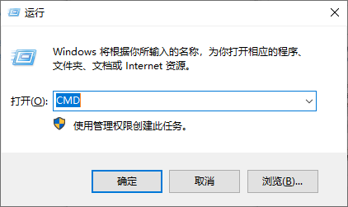
3. Press WIN + R at the same time and enter CMD to open the command line window
4. Enter ping 192.168.0.120. Check whether the network communication is normal. If there is a reply below, the Ethernet connection is normal.

Note: Please ensure the cell simulator is in the same network of the computer.

3. How to use it

This section details how to use the instrument, including installation of software and driver, functional configuration and applications, and parameters set up.

Direct Control

Prepare
Connect the Cell Simulator by TCP/IP

Initial the Cell Simulator
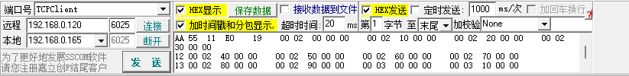
Taking SSCOM software as an example: select TCPClient for the port, set the port number to 6025, and enable HEX display and transmission.
Command:

AA 55 11 E1 19 00 00 00 00 00 55
Resp:

AA 55 11 B0 01 11 02 12 03 13 04 14 05 15 06 16 07 17 08 18 09 19 10 20 11 21 12 22 13 23 14 24 15 25 16 26 17 27 18 28 50

Cell Voltage Output

The voltage output of a cell can be set via a command by providing the channel and the voltage value. In addition,
calibration values (scale, offset) are used to adjust the voltage output for each cell.
The parameters of the voltage output of a cell

Command:

AA 55 11 E0 19
00 02 00 00 00 00 02 10 00 00 00 02 20 00 00 00 02 30 00 00
12 00 02 40 00 00 00 02 50 00 00 00 02 60 00 00 00 02 70 00 00
13 00 02 80 00 00 00 02 90 00 00 00 03 00 00 00 00 03 10 00 00
14 00 03 20 00 00 00 03 30 00 00 00 03 40 00 00 00 03 50 00 00
15 00 03 60 00 00 00 03 70 00 00 00 03 80 00 00 00 03 90 00 00
16 00 04 00 00 00 00 04 10 00 00 00 04 20 00 00 00 04 30 00 00
17 00 02 00 00 00 00 02 10 00 00 00 02 20 00 00 00 02 30 00 00
18 00 02 40 00 00 00 02 50 00 00 00 02 60 00 00 00 02 70 00 00
19 00 02 80 00 00 00 02 90 00 00 00 03 00 00 00 00 03 10 00 00
20 00 03 20 00 00 00 03 30 00 00 00 03 40 00 00 00 03 50 00 00
21 00 03 60 00 00 00 03 70 00 00 00 03 80 00 00 00 03 90 00 00
22 00 04 00 00 00 00 04 10 00 00 00 04 20 00 00 00 04 30 00 00
23 00 02 00 00 00 00 02 10 00 00 00 02 20 00 00 00 02 30 00 00
24 00 02 40 00 00 00 02 50 00 00 00 02 60 00 00 00 02 70 00 00
25 00 02 80 00 00 00 02 90 00 00 00 03 00 00 00 00 03 10 00 00
26 00 03 20 00 00 00 03 30 00 00 00 03 40 00 00 00 03 50 00 00
27 00 03 60 00 00 00 03 70 00 00 00 03 80 00 00 00 03 90 00 00
28 00 04 00 00 00 00 04 10 00 00 00 04 20 00 00 00 04 30 00 00
08 01 00 01 20 00 00 55

Cell Votage Measurement
The board offers voltage measurement by sending command and providing the channel. In addition, calibration values (scale, offset) are used to adjust the current measurement for each cell.
● Command:

AA 55 11 E1 19 00 00 00 00 00 55

Cell Current Measurement

The board offers current measurement by sending command and providing the channel. In addition, calibration values (scale, offset) are used to adjust the current measurement for each cell.
The current measurement has two ranges, a low current and a high current range. The parameters of the low current measurement of a cell

● Command:

AA 55 11 E2 19 00 00 00 00 00 55

Fault Simulation:

You may set 4 status of cell channels: Open, No fault, Reversed and Short cut.
When turn on the cell simulator, it will stay at “Open” by default.
Please set to “No fault”, if you want normal output.
 | OPEN
CH1 | @11_CLRDIG=5; | @11_CLRDIG=6; | @11_CLRDIG=7; | @11_CLRDIG=8;
CH2 | @11_CLRDIG=10; | @11_CLRDIG=11; | @11_CLRDIG=12; | @11_CLRDIG=13;
CH3 | @11_CLRDIG=15; | @11_CLRDIG=16; | @11_CLRDIG=17; | @11_CLRDIG=18;
CH4 | @11_CLRDIG=20; | @11_CLRDIG=21; | @11_CLRDIG=22; | @11_CLRDIG=23;
CH5 | @11_CLRDIG=25; | @11_CLRDIG=26; | @11_CLRDIG=27; | @11_CLRDIG=28;
CH6 | @11_CLRDIG=30; | @11_CLRDIG=31; | @11_CLRDIG=32; | @11_CLRDIG=33;
CH7 | @11_CLRDIG=35; | @11_CLRDIG=36; | @11_CLRDIG=37; | @11_CLRDIG=38;
CH8 | @11_CLRDIG=40; | @11_CLRDIG=41; | @11_CLRDIG=42; | @11_CLRDIG=43;
CH9 | @11_CLRDIG=45; | @11_CLRDIG=46; | @11_CLRDIG=47; | @11_CLRDIG=48;
CH10 | @11_CLRDIG=50; | @11_CLRDIG=51; | @11_CLRDIG=52; | @11_CLRDIG=53;
CH11 | @11_CLRDIG=55; | @11_CLRDIG=56; | @11_CLRDIG=57; | @11_CLRDIG=58;
CH12 | @11_CLRDIG=60; | @11_CLRDIG=61; | @11_CLRDIG=62; | @11_CLRDIG=63;
CH13 | @11_CLRDIG=65; | @11_CLRDIG=66; | @11_CLRDIG=67; | @11_CLRDIG=68;
CH14 | @11_CLRDIG=70; | @11_CLRDIG=71; | @11_CLRDIG=72; | @11_CLRDIG=73;
CH15 | @11_CLRDIG=75; | @11_CLRDIG=76; | @11_CLRDIG=77; | @11_CLRDIG=78;
CH16 | @11_CLRDIG=80; | @11_CLRDIG=81; | @11_CLRDIG=82; | @11_CLRDIG=83;
CH17 | @11_CLRDIG=85; | @11_CLRDIG=86; | @11_CLRDIG=87; | @11_CLRDIG=88;
CH18 | @11_CLRDIG=90; | @11_CLRDIG=91; | @11_CLRDIG=92; | @11_CLRDIG=93;
CH19 | @11_CLRDIG=95; | @11_CLRDIG=96; | @11_CLRDIG=97; | @11_CLRDIG=98;
CH20 | @11_CLRDIG=100; | @11_CLRDIG=101; | @11_CLRDIG=102; | @11_CLRDIG=103;
CH21 | @11_CLRDIG=105; | @11_CLRDIG=106; | @11_CLRDIG=107; | @11_CLRDIG=108;
CH22 | @11_CLRDIG=110; | @11_CLRDIG=111; | @11_CLRDIG=112; | @11_CLRDIG=113;
CH23 | @11_CLRDIG=115; | @11_CLRDIG=116; | @11_CLRDIG=117; | @11_CLRDIG=118;
CH24 | @11_CLRDIG=120; | @11_CLRDIG=121; | @11_CLRDIG=122; | @11_CLRDIG=123;
CH25 | @11_CLRDIG=125; | @11_CLRDIG=126; | @11_CLRDIG=127; | @11_CLRDIG=128;
CH26 | @11_CLRDIG=130; | @11_CLRDIG=131; | @11_CLRDIG=132; | @11_CLRDIG=133;
CH27 | @11_CLRDIG=135; | @11_CLRDIG=136; | @11_CLRDIG=137; | @11_CLRDIG=138;
CH28 | @11_CLRDIG=140; | @11_CLRDIG=141; | @11_CLRDIG=142; | @11_CLRDIG=143;
CH29 | @11_CLRDIG=145; | @11_CLRDIG=146; | @11_CLRDIG=147; | @11_CLRDIG=148;
CH30 | @11_CLRDIG=150; | @11_CLRDIG=151; | @11_CLRDIG=152; | @11_CLRDIG=153;
CH31 | @11_CLRDIG=155; | @11_CLRDIG=156; | @11_CLRDIG=157; | @11_CLRDIG=158;
CH32 | @11_CLRDIG=160; | @11_CLRDIG=161; | @11_CLRDIG=162; | @11_CLRDIG=163;
CH33 | @11_CLRDIG=165; | @11_CLRDIG=166; | @11_CLRDIG=167; | @11_CLRDIG=168;
CH34 | @11_CLRDIG=170; | @11_CLRDIG=171; | @11_CLRDIG=172; | @11_CLRDIG=173;
CH35 | @11_CLRDIG=175; | @11_CLRDIG=176; | @11_CLRDIG=177; | @11_CLRDIG=178;
CH36 | @11_CLRDIG=180; | @11_CLRDIG=181; | @11_CLRDIG=182; | @11_CLRDIG=183;
CH37 | @11_CLRDIG=185; | @11_CLRDIG=186; | @11_CLRDIG=187; | @11_CLRDIG=188;
CH38 | @11_CLRDIG=190; | @11_CLRDIG=191; | @11_CLRDIG=192; | @11_CLRDIG=193;
CH39 | @11_CLRDIG=195; | @11_CLRDIG=196; | @11_CLRDIG=197; | @11_CLRDIG=198;
CH40 | @11_CLRDIG=200; | @11_CLRDIG=201; | @11_CLRDIG=202; | @11_CLRDIG=203;
CH41 | @11_CLRDIG=205; | @11_CLRDIG=206; | @11_CLRDIG=207; | @11_CLRDIG=208;
CH42 | @11_CLRDIG=210; | @11_CLRDIG=211; | @11_CLRDIG=212; | @11_CLRDIG=213;
CH43 | @11_CLRDIG=215; | @11_CLRDIG=216; | @11_CLRDIG=217; | @11_CLRDIG=218;
CH44 | @11_CLRDIG=220; | @11_CLRDIG=221; | @11_CLRDIG=222; | @11_CLRDIG=223;
CH45 | @11_CLRDIG=225; | @11_CLRDIG=226; | @11_CLRDIG=227; | @11_CLRDIG=228;
CH46 | @11_CLRDIG=230; | @11_CLRDIG=231; | @11_CLRDIG=232; | @11_CLRDIG=233;
CH47 | @11_CLRDIG=235; | @11_CLRDIG=236; | @11_CLRDIG=237; | @11_CLRDIG=238;
CH48 | @11_CLRDIG=240; | @11_CLRDIG=241; | @11_CLRDIG=242; | @11_CLRDIG=243;
CH49 | @11_CLRDIG=245; | @11_CLRDIG=246; | @11_CLRDIG=247; | @11_CLRDIG=248;
CH50 | @11_CLRDIG=250; | @11_CLRDIG=251; | @11_CLRDIG=252; | @11_CLRDIG=253;
CH51 | @11_CLRDIG=255; | @11_CLRDIG=256; | @11_CLRDIG=257; | @11_CLRDIG=258;
CH52 | @11_CLRDIG=260; | @11_CLRDIG=261; | @11_CLRDIG=262; | @11_CLRDIG=263;
CH53 | @11_CLRDIG=265; | @11_CLRDIG=266; | @11_CLRDIG=267; | @11_CLRDIG=268;
CH54 | @11_CLRDIG=270; | @11_CLRDIG=271; | @11_CLRDIG=272; | @11_CLRDIG=273;
CH55 | @11_CLRDIG=275; | @11_CLRDIG=276; | @11_CLRDIG=277; | @11_CLRDIG=278;
CH56 | @11_CLRDIG=280; | @11_CLRDIG=281; | @11_CLRDIG=282; | @11_CLRDIG=283;
CH57 | @11_CLRDIG=285; | @11_CLRDIG=286; | @11_CLRDIG=287; | @11_CLRDIG=288;
CH58 | @11_CLRDIG=290; | @11_CLRDIG=291; | @11_CLRDIG=292; | @11_CLRDIG=293;
CH59 | @11_CLRDIG=295; | @11_CLRDIG=296; | @11_CLRDIG=297; | @11_CLRDIG=298;
CH60 | @11_CLRDIG=300; | @11_CLRDIG=301; | @11_CLRDIG=302; | @11_CLRDIG=303;
CH61 | @11_CLRDIG=305; | @11_CLRDIG=306; | @11_CLRDIG=307; | @11_CLRDIG=308;
CH62 | @11_CLRDIG=310; | @11_CLRDIG=311; | @11_CLRDIG=312; | @11_CLRDIG=313;
CH63 | @11_CLRDIG=315; | @11_CLRDIG=316; | @11_CLRDIG=317; | @11_CLRDIG=318;
CH64 | @11_CLRDIG=320; | @11_CLRDIG=321; | @11_CLRDIG=322; | @11_CLRDIG=323;
CH65 | @11_CLRDIG=325; | @11_CLRDIG=326; | @11_CLRDIG=327; | @11_CLRDIG=328;
CH66 | @11_CLRDIG=330; | @11_CLRDIG=331; | @11_CLRDIG=332; | @11_CLRDIG=333;
CH67 | @11_CLRDIG=335; | @11_CLRDIG=336; | @11_CLRDIG=337; | @11_CLRDIG=338;
CH68 | @11_CLRDIG=340; | @11_CLRDIG=341; | @11_CLRDIG=342; | @11_CLRDIG=343;
CH69 | @11_CLRDIG=345; | @11_CLRDIG=346; | @11_CLRDIG=347; | @11_CLRDIG=348;
CH70 | @11_CLRDIG=350; | @11_CLRDIG=351; | @11_CLRDIG=352; | @11_CLRDIG=353;
CH71 | @11_CLRDIG=355; | @11_CLRDIG=356; | @11_CLRDIG=357; | @11_CLRDIG=358;
CH72 | @11_CLRDIG=360; | @11_CLRDIG=361; | @11_CLRDIG=362; | @11_CLRDIG=363;

 | NO FAULT
CH1 | @11_SETDIG=5; | @11_SETDIG=6; | @11_CLRDIG=7; | @11_CLRDIG=8;
CH2 | @11_SETDIG=10; | @11_SETDIG=11; | @11_CLRDIG=12; | @11_CLRDIG=13;
CH3 | @11_SETDIG=15; | @11_SETDIG=16; | @11_CLRDIG=17; | @11_CLRDIG=18;
CH4 | @11_SETDIG=20; | @11_SETDIG=21; | @11_CLRDIG=22; | @11_CLRDIG=23;
CH5 | @11_SETDIG=25; | @11_SETDIG=26; | @11_CLRDIG=27; | @11_CLRDIG=28;
CH6 | @11_SETDIG=30; | @11_SETDIG=31; | @11_CLRDIG=32; | @11_CLRDIG=33;
CH7 | @11_SETDIG=35; | @11_SETDIG=36; | @11_CLRDIG=37; | @11_CLRDIG=38;
CH8 | @11_SETDIG=40; | @11_SETDIG=41; | @11_CLRDIG=42; | @11_CLRDIG=43;
CH9 | @11_SETDIG=45; | @11_SETDIG=46; | @11_CLRDIG=47; | @11_CLRDIG=48;
CH10 | @11_SETDIG=50; | @11_SETDIG=51; | @11_CLRDIG=52; | @11_CLRDIG=53;
CH11 | @11_SETDIG=55; | @11_SETDIG=56; | @11_CLRDIG=57; | @11_CLRDIG=58;
CH12 | @11_SETDIG=60; | @11_SETDIG=61; | @11_CLRDIG=62; | @11_CLRDIG=63;
CH13 | @11_SETDIG=65; | @11_SETDIG=66; | @11_CLRDIG=67; | @11_CLRDIG=68;
CH14 | @11_SETDIG=70; | @11_SETDIG=71; | @11_CLRDIG=72; | @11_CLRDIG=73;
CH15 | @11_SETDIG=75; | @11_SETDIG=76; | @11_CLRDIG=77; | @11_CLRDIG=78;
CH16 | @11_SETDIG=80; | @11_SETDIG=81; | @11_CLRDIG=82; | @11_CLRDIG=83;
CH17 | @11_SETDIG=85; | @11_SETDIG=86; | @11_CLRDIG=87; | @11_CLRDIG=88;
CH18 | @11_SETDIG=90; | @11_SETDIG=91; | @11_CLRDIG=92; | @11_CLRDIG=93;
CH19 | @11_SETDIG=95; | @11_SETDIG=96; | @11_CLRDIG=97; | @11_CLRDIG=98;
CH20 | @11_SETDIG=100; | @11_SETDIG=101; | @11_CLRDIG=102; | @11_CLRDIG=103;
CH21 | @11_SETDIG=105; | @11_SETDIG=106; | @11_CLRDIG=107; | @11_CLRDIG=108;
CH22 | @11_SETDIG=110; | @11_SETDIG=111; | @11_CLRDIG=112; | @11_CLRDIG=113;
CH23 | @11_SETDIG=115; | @11_SETDIG=116; | @11_CLRDIG=117; | @11_CLRDIG=118;
CH24 | @11_SETDIG=120; | @11_SETDIG=121; | @11_CLRDIG=122; | @11_CLRDIG=123;
CH25 | @11_SETDIG=125; | @11_SETDIG=126; | @11_CLRDIG=127; | @11_CLRDIG=128;
CH26 | @11_SETDIG=130; | @11_SETDIG=131; | @11_CLRDIG=132; | @11_CLRDIG=133;
CH27 | @11_SETDIG=135; | @11_SETDIG=136; | @11_CLRDIG=137; | @11_CLRDIG=138;
CH28 | @11_SETDIG=140; | @11_SETDIG=141; | @11_CLRDIG=142; | @11_CLRDIG=143;
CH29 | @11_SETDIG=145; | @11_SETDIG=146; | @11_CLRDIG=147; | @11_CLRDIG=148;
CH30 | @11_SETDIG=150; | @11_SETDIG=151; | @11_CLRDIG=152; | @11_CLRDIG=153;
CH31 | @11_SETDIG=155; | @11_SETDIG=156; | @11_CLRDIG=157; | @11_CLRDIG=158;
CH32 | @11_SETDIG=160; | @11_SETDIG=161; | @11_CLRDIG=162; | @11_CLRDIG=163;
CH33 | @11_SETDIG=165; | @11_SETDIG=166; | @11_CLRDIG=167; | @11_CLRDIG=168;
CH34 | @11_SETDIG=170; | @11_SETDIG=171; | @11_CLRDIG=172; | @11_CLRDIG=173;
CH35 | @11_SETDIG=175; | @11_SETDIG=176; | @11_CLRDIG=177; | @11_CLRDIG=178;
CH36 | @11_SETDIG=180; | @11_SETDIG=181; | @11_CLRDIG=182; | @11_CLRDIG=183;
CH37 | @11_SETDIG=185; | @11_SETDIG=186; | @11_CLRDIG=187; | @11_CLRDIG=188;
CH38 | @11_SETDIG=190; | @11_SETDIG=191; | @11_CLRDIG=192; | @11_CLRDIG=193;
CH39 | @11_SETDIG=195; | @11_SETDIG=196; | @11_CLRDIG=197; | @11_CLRDIG=198;
CH40 | @11_SETDIG=200; | @11_SETDIG=201; | @11_CLRDIG=202; | @11_CLRDIG=203;
CH41 | @11_SETDIG=205; | @11_SETDIG=206; | @11_CLRDIG=207; | @11_CLRDIG=208;
CH42 | @11_SETDIG=210; | @11_SETDIG=211; | @11_CLRDIG=212; | @11_CLRDIG=213;
CH43 | @11_SETDIG=215; | @11_SETDIG=216; | @11_CLRDIG=217; | @11_CLRDIG=218;
CH44 | @11_SETDIG=220; | @11_SETDIG=221; | @11_CLRDIG=222; | @11_CLRDIG=223;
CH45 | @11_SETDIG=225; | @11_SETDIG=226; | @11_CLRDIG=227; | @11_CLRDIG=228;
CH46 | @11_SETDIG=230; | @11_SETDIG=231; | @11_CLRDIG=232; | @11_CLRDIG=233;
CH47 | @11_SETDIG=235; | @11_SETDIG=236; | @11_CLRDIG=237; | @11_CLRDIG=238;
CH48 | @11_SETDIG=240; | @11_SETDIG=241; | @11_CLRDIG=242; | @11_CLRDIG=243;
CH49 | @11_SETDIG=245; | @11_SETDIG=246; | @11_CLRDIG=247; | @11_CLRDIG=248;
CH50 | @11_SETDIG=250; | @11_SETDIG=251; | @11_CLRDIG=252; | @11_CLRDIG=253;
CH51 | @11_SETDIG=255; | @11_SETDIG=256; | @11_CLRDIG=257; | @11_CLRDIG=258;
CH52 | @11_SETDIG=260; | @11_SETDIG=261; | @11_CLRDIG=262; | @11_CLRDIG=263;
CH53 | @11_SETDIG=265; | @11_SETDIG=266; | @11_CLRDIG=267; | @11_CLRDIG=268;
CH54 | @11_SETDIG=270; | @11_SETDIG=271; | @11_CLRDIG=272; | @11_CLRDIG=273;
CH55 | @11_SETDIG=275; | @11_SETDIG=276; | @11_CLRDIG=277; | @11_CLRDIG=278;
CH56 | @11_SETDIG=280; | @11_SETDIG=281; | @11_CLRDIG=282; | @11_CLRDIG=283;
CH57 | @11_SETDIG=285; | @11_SETDIG=286; | @11_CLRDIG=287; | @11_CLRDIG=288;
CH58 | @11_SETDIG=290; | @11_SETDIG=291; | @11_CLRDIG=292; | @11_CLRDIG=293;
CH59 | @11_SETDIG=295; | @11_SETDIG=296; | @11_CLRDIG=297; | @11_CLRDIG=298;
CH60 | @11_SETDIG=300; | @11_SETDIG=301; | @11_CLRDIG=302; | @11_CLRDIG=303;
CH61 | @11_SETDIG=305; | @11_SETDIG=306; | @11_CLRDIG=307; | @11_CLRDIG=308;
CH62 | @11_SETDIG=310; | @11_SETDIG=311; | @11_CLRDIG=312; | @11_CLRDIG=313;
CH63 | @11_SETDIG=315; | @11_SETDIG=316; | @11_CLRDIG=317; | @11_CLRDIG=318;
CH64 | @11_SETDIG=320; | @11_SETDIG=321; | @11_CLRDIG=322; | @11_CLRDIG=323;
CH65 | @11_SETDIG=325; | @11_SETDIG=326; | @11_CLRDIG=327; | @11_CLRDIG=328;
CH66 | @11_SETDIG=330; | @11_SETDIG=331; | @11_CLRDIG=332; | @11_CLRDIG=333;
CH67 | @11_SETDIG=335; | @11_SETDIG=336; | @11_CLRDIG=337; | @11_CLRDIG=338;
CH68 | @11_SETDIG=340; | @11_SETDIG=341; | @11_CLRDIG=342; | @11_CLRDIG=343;
CH69 | @11_SETDIG=345; | @11_SETDIG=346; | @11_CLRDIG=347; | @11_CLRDIG=348;
CH70 | @11_SETDIG=350; | @11_SETDIG=351; | @11_CLRDIG=352; | @11_CLRDIG=353;
CH71 | @11_SETDIG=355; | @11_SETDIG=356; | @11_CLRDIG=357; | @11_CLRDIG=358;
CH72 | @11_SETDIG=360; | @11_SETDIG=361; | @11_CLRDIG=362; | @11_CLRDIG=363;

 | REVERSED
CH1 | @11_SETDIG=5; | @11_CLRDIG=6; | @11_SETDIG=7; | @11_CLRDIG=8;
CH2 | @11_SETDIG=10; | @11_CLRDIG=11; | @11_SETDIG=12; | @11_CLRDIG=13;
CH3 | @11_SETDIG=15; | @11_CLRDIG=16; | @11_SETDIG=17; | @11_CLRDIG=18;
CH4 | @11_SETDIG=20; | @11_CLRDIG=21; | @11_SETDIG=22; | @11_CLRDIG=23;
CH5 | @11_SETDIG=25; | @11_CLRDIG=26; | @11_SETDIG=27; | @11_CLRDIG=28;
CH6 | @11_SETDIG=30; | @11_CLRDIG=31; | @11_SETDIG=32; | @11_CLRDIG=33;
CH7 | @11_SETDIG=35; | @11_CLRDIG=36; | @11_SETDIG=37; | @11_CLRDIG=38;
CH8 | @11_SETDIG=40; | @11_CLRDIG=41; | @11_SETDIG=42; | @11_CLRDIG=43;
CH9 | @11_SETDIG=45; | @11_CLRDIG=46; | @11_SETDIG=47; | @11_CLRDIG=48;
CH10 | @11_SETDIG=50; | @11_CLRDIG=51; | @11_SETDIG=52; | @11_CLRDIG=53;
CH11 | @11_SETDIG=55; | @11_CLRDIG=56; | @11_SETDIG=57; | @11_CLRDIG=58;
CH12 | @11_SETDIG=60; | @11_CLRDIG=61; | @11_SETDIG=62; | @11_CLRDIG=63;
CH13 | @11_SETDIG=65; | @11_CLRDIG=66; | @11_SETDIG=67; | @11_CLRDIG=68;
CH14 | @11_SETDIG=70; | @11_CLRDIG=71; | @11_SETDIG=72; | @11_CLRDIG=73;
CH15 | @11_SETDIG=75; | @11_CLRDIG=76; | @11_SETDIG=77; | @11_CLRDIG=78;
CH16 | @11_SETDIG=80; | @11_CLRDIG=81; | @11_SETDIG=82; | @11_CLRDIG=83;
CH17 | @11_SETDIG=85; | @11_CLRDIG=86; | @11_SETDIG=87; | @11_CLRDIG=88;
CH18 | @11_SETDIG=90; | @11_CLRDIG=91; | @11_SETDIG=92; | @11_CLRDIG=93;
CH19 | @11_SETDIG=95; | @11_CLRDIG=96; | @11_SETDIG=97; | @11_CLRDIG=98;
CH20 | @11_SETDIG=100; | @11_CLRDIG=101; | @11_SETDIG=102; | @11_CLRDIG=103;
CH21 | @11_SETDIG=105; | @11_CLRDIG=106; | @11_SETDIG=107; | @11_CLRDIG=108;
CH22 | @11_SETDIG=110; | @11_CLRDIG=111; | @11_SETDIG=112; | @11_CLRDIG=113;
CH23 | @11_SETDIG=115; | @11_CLRDIG=116; | @11_SETDIG=117; | @11_CLRDIG=118;
CH24 | @11_SETDIG=120; | @11_CLRDIG=121; | @11_SETDIG=122; | @11_CLRDIG=123;
CH25 | @11_SETDIG=125; | @11_CLRDIG=126; | @11_SETDIG=127; | @11_CLRDIG=128;
CH26 | @11_SETDIG=130; | @11_CLRDIG=131; | @11_SETDIG=132; | @11_CLRDIG=133;
CH27 | @11_SETDIG=135; | @11_CLRDIG=136; | @11_SETDIG=137; | @11_CLRDIG=138;
CH28 | @11_SETDIG=140; | @11_CLRDIG=141; | @11_SETDIG=142; | @11_CLRDIG=143;
CH29 | @11_SETDIG=145; | @11_CLRDIG=146; | @11_SETDIG=147; | @11_CLRDIG=148;
CH30 | @11_SETDIG=150; | @11_CLRDIG=151; | @11_SETDIG=152; | @11_CLRDIG=153;
CH31 | @11_SETDIG=155; | @11_CLRDIG=156; | @11_SETDIG=157; | @11_CLRDIG=158;
CH32 | @11_SETDIG=160; | @11_CLRDIG=161; | @11_SETDIG=162; | @11_CLRDIG=163;
CH33 | @11_SETDIG=165; | @11_CLRDIG=166; | @11_SETDIG=167; | @11_CLRDIG=168;
CH34 | @11_SETDIG=170; | @11_CLRDIG=171; | @11_SETDIG=172; | @11_CLRDIG=173;
CH35 | @11_SETDIG=175; | @11_CLRDIG=176; | @11_SETDIG=177; | @11_CLRDIG=178;
CH36 | @11_SETDIG=180; | @11_CLRDIG=181; | @11_SETDIG=182; | @11_CLRDIG=183;
CH37 | @11_SETDIG=185; | @11_CLRDIG=186; | @11_SETDIG=187; | @11_CLRDIG=188;
CH38 | @11_SETDIG=190; | @11_CLRDIG=191; | @11_SETDIG=192; | @11_CLRDIG=193;
CH39 | @11_SETDIG=195; | @11_CLRDIG=196; | @11_SETDIG=197; | @11_CLRDIG=198;
CH40 | @11_SETDIG=200; | @11_CLRDIG=201; | @11_SETDIG=202; | @11_CLRDIG=203;
CH41 | @11_SETDIG=205; | @11_CLRDIG=206; | @11_SETDIG=207; | @11_CLRDIG=208;
CH42 | @11_SETDIG=210; | @11_CLRDIG=211; | @11_SETDIG=212; | @11_CLRDIG=213;
CH43 | @11_SETDIG=215; | @11_CLRDIG=216; | @11_SETDIG=217; | @11_CLRDIG=218;
CH44 | @11_SETDIG=220; | @11_CLRDIG=221; | @11_SETDIG=222; | @11_CLRDIG=223;
CH45 | @11_SETDIG=225; | @11_CLRDIG=226; | @11_SETDIG=227; | @11_CLRDIG=228;
CH46 | @11_SETDIG=230; | @11_CLRDIG=231; | @11_SETDIG=232; | @11_CLRDIG=233;
CH47 | @11_SETDIG=235; | @11_CLRDIG=236; | @11_SETDIG=237; | @11_CLRDIG=238;
CH48 | @11_SETDIG=240; | @11_CLRDIG=241; | @11_SETDIG=242; | @11_CLRDIG=243;
CH49 | @11_SETDIG=245; | @11_CLRDIG=246; | @11_SETDIG=247; | @11_CLRDIG=248;
CH50 | @11_SETDIG=250; | @11_CLRDIG=251; | @11_SETDIG=252; | @11_CLRDIG=253;
CH51 | @11_SETDIG=255; | @11_CLRDIG=256; | @11_SETDIG=257; | @11_CLRDIG=258;
CH52 | @11_SETDIG=260; | @11_CLRDIG=261; | @11_SETDIG=262; | @11_CLRDIG=263;
CH53 | @11_SETDIG=265; | @11_CLRDIG=266; | @11_SETDIG=267; | @11_CLRDIG=268;
CH54 | @11_SETDIG=270; | @11_CLRDIG=271; | @11_SETDIG=272; | @11_CLRDIG=273;
CH55 | @11_SETDIG=275; | @11_CLRDIG=276; | @11_SETDIG=277; | @11_CLRDIG=278;
CH56 | @11_SETDIG=280; | @11_CLRDIG=281; | @11_SETDIG=282; | @11_CLRDIG=283;
CH57 | @11_SETDIG=285; | @11_CLRDIG=286; | @11_SETDIG=287; | @11_CLRDIG=288;
CH58 | @11_SETDIG=290; | @11_CLRDIG=291; | @11_SETDIG=292; | @11_CLRDIG=293;
CH59 | @11_SETDIG=295; | @11_CLRDIG=296; | @11_SETDIG=297; | @11_CLRDIG=298;
CH60 | @11_SETDIG=300; | @11_CLRDIG=301; | @11_SETDIG=302; | @11_CLRDIG=303;
CH61 | @11_SETDIG=305; | @11_CLRDIG=306; | @11_SETDIG=307; | @11_CLRDIG=308;
CH62 | @11_SETDIG=310; | @11_CLRDIG=311; | @11_SETDIG=312; | @11_CLRDIG=313;
CH63 | @11_SETDIG=315; | @11_CLRDIG=316; | @11_SETDIG=317; | @11_CLRDIG=318;
CH64 | @11_SETDIG=320; | @11_CLRDIG=321; | @11_SETDIG=322; | @11_CLRDIG=323;
CH65 | @11_SETDIG=325; | @11_CLRDIG=326; | @11_SETDIG=327; | @11_CLRDIG=328;
CH66 | @11_SETDIG=330; | @11_CLRDIG=331; | @11_SETDIG=332; | @11_CLRDIG=333;
CH67 | @11_SETDIG=335; | @11_CLRDIG=336; | @11_SETDIG=337; | @11_CLRDIG=338;
CH68 | @11_SETDIG=340; | @11_CLRDIG=341; | @11_SETDIG=342; | @11_CLRDIG=343;
CH69 | @11_SETDIG=345; | @11_CLRDIG=346; | @11_SETDIG=347; | @11_CLRDIG=348;
CH70 | @11_SETDIG=350; | @11_CLRDIG=351; | @11_SETDIG=352; | @11_CLRDIG=353;
CH71 | @11_SETDIG=355; | @11_CLRDIG=356; | @11_SETDIG=357; | @11_CLRDIG=358;
CH72 | @11_SETDIG=360; | @11_CLRDIG=361; | @11_SETDIG=362; | @11_CLRDIG=363;

 | SHORTCUT
CH1 | @11_CLRDIG=5; | @11_CLRDIG=6; | @11_CLRDIG=7; | @11_SETDIG=8;
CH2 | @11_CLRDIG=10; | @11_CLRDIG=11; | @11_CLRDIG=12; | @11_SETDIG=13;
CH3 | @11_CLRDIG=15; | @11_CLRDIG=16; | @11_CLRDIG=17; | @11_SETDIG=18;
CH4 | @11_CLRDIG=20; | @11_CLRDIG=21; | @11_CLRDIG=22; | @11_SETDIG=23;
CH5 | @11_CLRDIG=25; | @11_CLRDIG=26; | @11_CLRDIG=27; | @11_SETDIG=28;
CH6 | @11_CLRDIG=30; | @11_CLRDIG=31; | @11_CLRDIG=32; | @11_SETDIG=33;
CH7 | @11_CLRDIG=35; | @11_CLRDIG=36; | @11_CLRDIG=37; | @11_SETDIG=38;
CH8 | @11_CLRDIG=40; | @11_CLRDIG=41; | @11_CLRDIG=42; | @11_SETDIG=43;
CH9 | @11_CLRDIG=45; | @11_CLRDIG=46; | @11_CLRDIG=47; | @11_SETDIG=48;
CH10 | @11_CLRDIG=50; | @11_CLRDIG=51; | @11_CLRDIG=52; | @11_SETDIG=53;
CH11 | @11_CLRDIG=55; | @11_CLRDIG=56; | @11_CLRDIG=57; | @11_SETDIG=58;
CH12 | @11_CLRDIG=60; | @11_CLRDIG=61; | @11_CLRDIG=62; | @11_SETDIG=63;
CH13 | @11_CLRDIG=65; | @11_CLRDIG=66; | @11_CLRDIG=67; | @11_SETDIG=68;
CH14 | @11_CLRDIG=70; | @11_CLRDIG=71; | @11_CLRDIG=72; | @11_SETDIG=73;
CH15 | @11_CLRDIG=75; | @11_CLRDIG=76; | @11_CLRDIG=77; | @11_SETDIG=78;
CH16 | @11_CLRDIG=80; | @11_CLRDIG=81; | @11_CLRDIG=82; | @11_SETDIG=83;
CH17 | @11_CLRDIG=85; | @11_CLRDIG=86; | @11_CLRDIG=87; | @11_SETDIG=88;
CH18 | @11_CLRDIG=90; | @11_CLRDIG=91; | @11_CLRDIG=92; | @11_SETDIG=93;
CH19 | @11_CLRDIG=95; | @11_CLRDIG=96; | @11_CLRDIG=97; | @11_SETDIG=98;
CH20 | @11_CLRDIG=100; | @11_CLRDIG=101; | @11_CLRDIG=102; | @11_SETDIG=103;
CH21 | @11_CLRDIG=105; | @11_CLRDIG=106; | @11_CLRDIG=107; | @11_SETDIG=108;
CH22 | @11_CLRDIG=110; | @11_CLRDIG=111; | @11_CLRDIG=112; | @11_SETDIG=113;
CH23 | @11_CLRDIG=115; | @11_CLRDIG=116; | @11_CLRDIG=117; | @11_SETDIG=118;
CH24 | @11_CLRDIG=120; | @11_CLRDIG=121; | @11_CLRDIG=122; | @11_SETDIG=123;
CH25 | @11_CLRDIG=125; | @11_CLRDIG=126; | @11_CLRDIG=127; | @11_SETDIG=128;
CH26 | @11_CLRDIG=130; | @11_CLRDIG=131; | @11_CLRDIG=132; | @11_SETDIG=133;
CH27 | @11_CLRDIG=135; | @11_CLRDIG=136; | @11_CLRDIG=137; | @11_SETDIG=138;
CH28 | @11_CLRDIG=140; | @11_CLRDIG=141; | @11_CLRDIG=142; | @11_SETDIG=143;
CH29 | @11_CLRDIG=145; | @11_CLRDIG=146; | @11_CLRDIG=147; | @11_SETDIG=148;
CH30 | @11_CLRDIG=150; | @11_CLRDIG=151; | @11_CLRDIG=152; | @11_SETDIG=153;
CH31 | @11_CLRDIG=155; | @11_CLRDIG=156; | @11_CLRDIG=157; | @11_SETDIG=158;
CH32 | @11_CLRDIG=160; | @11_CLRDIG=161; | @11_CLRDIG=162; | @11_SETDIG=163;
CH33 | @11_CLRDIG=165; | @11_CLRDIG=166; | @11_CLRDIG=167; | @11_SETDIG=168;
CH34 | @11_CLRDIG=170; | @11_CLRDIG=171; | @11_CLRDIG=172; | @11_SETDIG=173;
CH35 | @11_CLRDIG=175; | @11_CLRDIG=176; | @11_CLRDIG=177; | @11_SETDIG=178;
CH36 | @11_CLRDIG=180; | @11_CLRDIG=181; | @11_CLRDIG=182; | @11_SETDIG=183;
CH37 | @11_CLRDIG=185; | @11_CLRDIG=186; | @11_CLRDIG=187; | @11_SETDIG=188;
CH38 | @11_CLRDIG=190; | @11_CLRDIG=191; | @11_CLRDIG=192; | @11_SETDIG=193;
CH39 | @11_CLRDIG=195; | @11_CLRDIG=196; | @11_CLRDIG=197; | @11_SETDIG=198;
CH40 | @11_CLRDIG=200; | @11_CLRDIG=201; | @11_CLRDIG=202; | @11_SETDIG=203;
CH41 | @11_CLRDIG=205; | @11_CLRDIG=206; | @11_CLRDIG=207; | @11_SETDIG=208;
CH42 | @11_CLRDIG=210; | @11_CLRDIG=211; | @11_CLRDIG=212; | @11_SETDIG=213;
CH43 | @11_CLRDIG=215; | @11_CLRDIG=216; | @11_CLRDIG=217; | @11_SETDIG=218;
CH44 | @11_CLRDIG=220; | @11_CLRDIG=221; | @11_CLRDIG=222; | @11_SETDIG=223;
CH45 | @11_CLRDIG=225; | @11_CLRDIG=226; | @11_CLRDIG=227; | @11_SETDIG=228;
CH46 | @11_CLRDIG=230; | @11_CLRDIG=231; | @11_CLRDIG=232; | @11_SETDIG=233;
CH47 | @11_CLRDIG=235; | @11_CLRDIG=236; | @11_CLRDIG=237; | @11_SETDIG=238;
CH48 | @11_CLRDIG=240; | @11_CLRDIG=241; | @11_CLRDIG=242; | @11_SETDIG=243;
CH49 | @11_CLRDIG=245; | @11_CLRDIG=246; | @11_CLRDIG=247; | @11_SETDIG=248;
CH50 | @11_CLRDIG=250; | @11_CLRDIG=251; | @11_CLRDIG=252; | @11_SETDIG=253;
CH51 | @11_CLRDIG=255; | @11_CLRDIG=256; | @11_CLRDIG=257; | @11_SETDIG=258;
CH52 | @11_CLRDIG=260; | @11_CLRDIG=261; | @11_CLRDIG=262; | @11_SETDIG=263;
CH53 | @11_CLRDIG=265; | @11_CLRDIG=266; | @11_CLRDIG=267; | @11_SETDIG=268;
CH54 | @11_CLRDIG=270; | @11_CLRDIG=271; | @11_CLRDIG=272; | @11_SETDIG=273;
CH55 | @11_CLRDIG=275; | @11_CLRDIG=276; | @11_CLRDIG=277; | @11_SETDIG=278;
CH56 | @11_CLRDIG=280; | @11_CLRDIG=281; | @11_CLRDIG=282; | @11_SETDIG=283;
CH57 | @11_CLRDIG=285; | @11_CLRDIG=286; | @11_CLRDIG=287; | @11_SETDIG=288;
CH58 | @11_CLRDIG=290; | @11_CLRDIG=291; | @11_CLRDIG=292; | @11_SETDIG=293;
CH59 | @11_CLRDIG=295; | @11_CLRDIG=296; | @11_CLRDIG=297; | @11_SETDIG=298;
CH60 | @11_CLRDIG=300; | @11_CLRDIG=301; | @11_CLRDIG=302; | @11_SETDIG=303;
CH61 | @11_CLRDIG=305; | @11_CLRDIG=306; | @11_CLRDIG=307; | @11_SETDIG=308;
CH62 | @11_CLRDIG=310; | @11_CLRDIG=311; | @11_CLRDIG=312; | @11_SETDIG=313;
CH63 | @11_CLRDIG=315; | @11_CLRDIG=316; | @11_CLRDIG=317; | @11_SETDIG=318;
CH64 | @11_CLRDIG=320; | @11_CLRDIG=321; | @11_CLRDIG=322; | @11_SETDIG=323;
CH65 | @11_CLRDIG=325; | @11_CLRDIG=326; | @11_CLRDIG=327; | @11_SETDIG=328;
CH66 | @11_CLRDIG=330; | @11_CLRDIG=331; | @11_CLRDIG=332; | @11_SETDIG=333;
CH67 | @11_CLRDIG=335; | @11_CLRDIG=336; | @11_CLRDIG=337; | @11_SETDIG=338;
CH68 | @11_CLRDIG=340; | @11_CLRDIG=341; | @11_CLRDIG=342; | @11_SETDIG=343;
CH69 | @11_CLRDIG=345; | @11_CLRDIG=346; | @11_CLRDIG=347; | @11_SETDIG=348;
CH70 | @11_CLRDIG=350; | @11_CLRDIG=351; | @11_CLRDIG=352; | @11_SETDIG=353;
CH71 | @11_CLRDIG=355; | @11_CLRDIG=356; | @11_CLRDIG=357; | @11_SETDIG=358;

RTDS Protocol

3.5 Advanced configuration

In the software, the voltage measurement keeps sending by as a default timing. It cannot be changed. If you want to customize the process (like how often to send a response), you can send commands as the “Cells Simulation Board - User Manual” - section 1.8 Actions Sequencer.

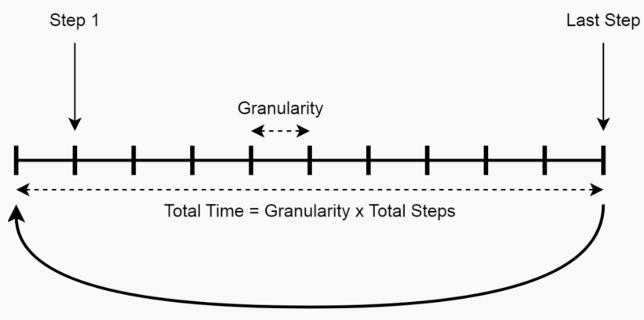

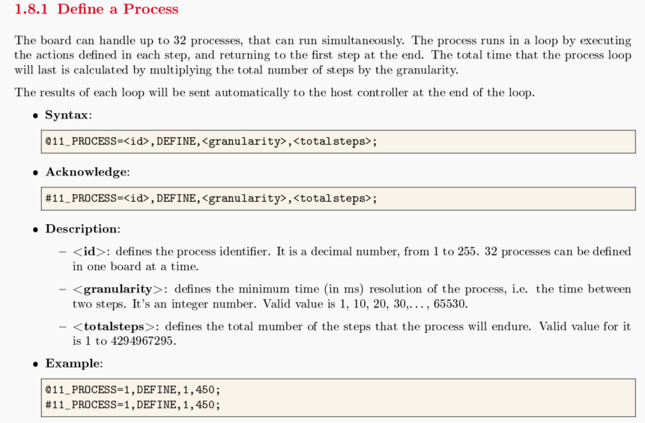

- Example

/* Process 1 to set all channels voltage */

@11_PROCESS=1,DEFINE,1,180;
@11_PROCESS=1,1,MSGTX,CAN1,CELL11,0XA100002000000055;
@11_PROCESS=1,61,MSGTX,CAN1,CELL12,0XA100002000000055;
@11_PROCESS=1,121,MSGTX,CAN1,CELL13,0XA100002000000055;
@11_PROCESS=1,END;

/* Process 2 to get all channels voltage */

@11_PROCESS=2,DEFINE,1,101;
@11_PROCESS=2,1,MSGTX,CAN1,CELL11,0XB10155;
@11_PROCESS=2,5,MSGTX,CAN1,CELL11,0XB10255;
@11_PROCESS=2,10,MSGTX,CAN1,CELL11,0XB10355;
@11_PROCESS=2,15,MSGTX,CAN1,CELL11,0XB10455;
@11_PROCESS=2,20,MSGTX,CAN1,CELL11,0XB10555;
@11_PROCESS=2,25,MSGTX,CAN1,CELL11,0XB10655;
@11_PROCESS=2,30,MSGTX,CAN1,CELL12,0XB10155;
@11_PROCESS=2,35,MSGTX,CAN1,CELL12,0XB10255;
@11_PROCESS=2,40,MSGTX,CAN1,CELL12,0XB10355;
@11_PROCESS=2,45,MSGTX,CAN1,CELL12,0XB10455;
@11_PROCESS=2,50,MSGTX,CAN1,CELL12,0XB10555;
@11_PROCESS=2,55,MSGTX,CAN1,CELL12,0XB10655;
@11_PROCESS=2,60,MSGTX,CAN1,CELL13,0XB10155;
@11_PROCESS=2,65,MSGTX,CAN1,CELL13,0XB10255;
@11_PROCESS=2,70,MSGTX,CAN1,CELL13,0XB10355;
@11_PROCESS=2,75,MSGTX,CAN1,CELL13,0XB10455;
@11_PROCESS=2,80,MSGTX,CAN1,CELL13,0XB10555;
@11_PROCESS=2,85,MSGTX,CAN1,CELL13,0XB10655;
@11_PROCESS=2,END;

/* Process 3 to get all channels current measurement current at high range */

@11_PROCESS=3,DEFINE,1,101;
@11_PROCESS=3,1,MSGTX,CAN1,CELL11,0XBB0155;
@11_PROCESS=3,5,MSGTX,CAN1,CELL11,0XBB0255;
@11_PROCESS=3,10,MSGTX,CAN1,CELL11,0XBB0355;
@11_PROCESS=3,15,MSGTX,CAN1,CELL11,0XBB0455;
@11_PROCESS=3,20,MSGTX,CAN1,CELL11,0XBB0555;
@11_PROCESS=3,25,MSGTX,CAN1,CELL11,0XBB0655;
@11_PROCESS=3,30,MSGTX,CAN1,CELL12,0XBB0155;
@11_PROCESS=3,35,MSGTX,CAN1,CELL12,0XBB0255;
@11_PROCESS=3,40,MSGTX,CAN1,CELL12,0XBB0355;
@11_PROCESS=3,45,MSGTX,CAN1,CELL12,0XBB0455;
@11_PROCESS=3,50,MSGTX,CAN1,CELL12,0XBB0555;
@11_PROCESS=3,55,MSGTX,CAN1,CELL12,0XBB0655;
@11_PROCESS=3,60,MSGTX,CAN1,CELL13,0XBB0155;
@11_PROCESS=3,65,MSGTX,CAN1,CELL13,0XBB0255;
@11_PROCESS=3,70,MSGTX,CAN1,CELL13,0XBB0355;
@11_PROCESS=3,75,MSGTX,CAN1,CELL13,0XBB0455;
@11_PROCESS=3,80,MSGTX,CAN1,CELL13,0XBB0555;
@11_PROCESS=3,85,MSGTX,CAN1,CELL13,0XBB0655;
@11_PROCESS=3,END;

● Command:

@11_PROCESS=1,START,LOOPS,1; // to start process 1 for once.
@11_PROCESS=1,STOP; // to stop process1

Note:
for the process of set voltage output, please use command: “@11_PROCESS=1,START,LOOPS,1;”
By process start and stop way, user can change voltage, current.

a3.4 Set and read by CAN communication

It’s also allowed user to set output voltage and read cell voltage and current by CAN.
- Connect CAN line to the cell simulator by any CAN tool.
- Send command to set the output voltage for each cell channel.
- Read voltage or current by CAN command.
- Detail commands see “Cells Simulation Board - User Manual”

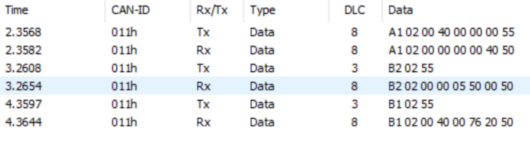

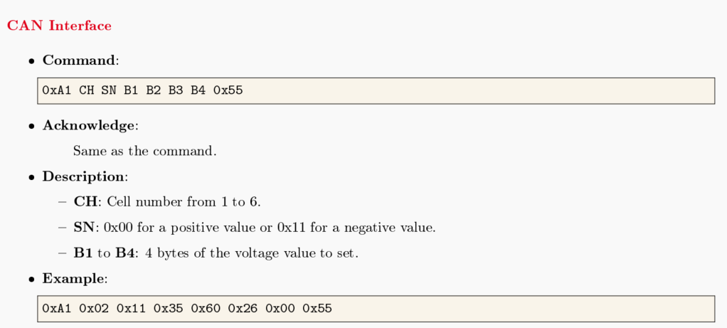

4. Technical specifications

♦ Main technical parameters

4.1. Main technical parameters

Analog voltage output | parameter
Channel | 18 channels
Resolution ratio | 16bit
Output voltage range (usual / maximum) | 0-7 V
Voltage accuracy | ±1m V
Charging current | 0-1A
Discharge current | -500 to 500 mA
Current accuracy | 1mA/±5u A

Connector interface | parameter
Ethernet | TCP/IP  10/100 Mbps link  Programmable source code, gateway, and mask ip
USB-C | USB 2.0  5V power supply
CAN | Standard CAN protocol for 500 Kbps

Environment
Working humidity | 10 – 90 RH% without condensation
Storage humidity | And 5 – 95% RH without condensation

5.FAQ
5.1 Connection warning

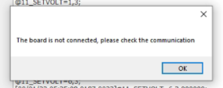

- Click and try to connect again
- Check USB/IP configuration and setup as section 2.4
- Plug the connector again

